

Smoking attributable mortality and hospital admissions for Wales, 2020-22
Authors:
- Chris Emmerson, Consultant in Public Health, Health Improvement Division, Public Health Wales
- Hugo Cosh, Principal Public Health Intelligence Analyst, Observatory Analytical Team, Public Health Wales
- Bethan Patterson, Advanced Public Health Intelligence Analyst Observatory Analytical Team, Public Health Wales
- Rebecca Hughes, Information Analyst, Health Improvement Division, Public Health Wales
Date: 24 September 2024

Contents
Smoking attributable mortality and hospital admissions for Wales, 2020-22 1
1 Executive Summary 3
2 Background 3
3 Method 3
4 Smoking attributable mortality in Wales, 2020-22 5
5 Smoking attributable hospital admissions in Wales, 2020-22 8
6 Appendix 1: Technical details related to calculation of smoking attributable mortality and hospital admissions in Wales 10
6.1 Sources of data 10
6.2 Additional notes on data and calculations used in this report 10

Executive Summary
Smoking remains a major cause of mortality and ill health in Wales. Over the period 2020-22, an estimated 3,845 deaths per year amongst those aged 35 and over in Wales were due to smoking. This means that on average 10.7% of all deaths in Wales amongst those aged 35 and over in these years were attributable to smoking.
The proportion of deaths attributable to smoking varies considerably by deprivation. Amongst those aged 35 and over living in the most deprived fifth of areas, 14.5% of all deaths were attributable to smoking in 2020-22. The European Age Standardised Rate (EASR) of smoking attributable mortality was 333 per 100,000 adults aged 35 and over in the most deprived fifth of areas, more than three times higher compared with the least deprived fifth.
Over the period 2020-22, an estimated 17,195 hospital admissions per year in Wales were due to smoking. This means that on average 3.4% of all hospital admissions in Wales amongst those aged 35 and over in these years were attributable to smoking.
The effect of COVID on population health and patterns of healthcare use mean that these figures are likely to be underestimates of the impact of smoking in Wales over this period.

Background
Smoking remains a major cause of mortality and ill health in Wales. In order to support stakeholders in tobacco control in Wales, including Welsh Government, Public Health Wales (PHW) and Local Health Boards, the Tobacco Control team in Public Health Wales commissioned the PHW Observatory to calculate smoking attributable mortality and hospital admissions figures for Wales.

Method
Following discussion with the PHW Observatory and the Office for Health Improvement and Disparities (OHID) in England, it was agreed that the method set out by Public Health England in 2020 represented the best current method for calculating smoking attributable fractions. Note that this means figures are not comparable to previously published smoking attributable mortality and hospital admissions for Wales.
There are well documented links between smoking and number of diseases such as a variety of cancers, respiratory disease, heart disease and mental ill health. For these conditions, it is possible to calculate the ratio of the probability of them occurring in the exposed group (smokers or ex-smokers) versus the probability of them occurring in the non-exposed group (never smoked). This is called a relative risk and is specific to each disease, age group and sex. In some cases, risk differs for smokers and ex-smokers. These relative risks are combined with smoking prevalence information to create a smoking attributable fraction, which is the proportion of a disease that can be attributed to smoking. These are used to calculate various indicators for smoking-attributable mortality and hospital admissions¹.
All figures provided in this report are based on annual averages or overall rates for the period 2020-22 for all persons resident in Wales aged 35 and over. Only a very small number of individuals under 35 are admitted to hospital or die due to smoking related illnesses, and although smoking can harm health even in its early stages, it is usually many years before these harms require hospitalisation or lead to premature death. Estimates for smoking related harms that include the entire population are therefore likely to be less precise and useful for informing public health action.
It should be noted that the figures presented in this report will have been affected by the COVID pandemic and should therefore be interpreted with caution. It is likely that during the pandemic period, the number of deaths attributable to smoking will have been underestimated. This is because, for example, if person X had terminal cancer and then died from COVID-19, it is possible that COVID would be listed as the underlying cause of death on the death certificate. As a result, person X would not be included in the figures shown in this file, despite having a smoking-attributable disease that would likely have been listed as their underlying cause of death in non-pandemic circumstances.
It is likely that during the COVID pandemic period, the number of hospital admissions attributable to smoking will be underestimated for the period described in the report and also lower than would have been expected in a period unaffected by COVID. This is because, for example, if person X was dying from cancer and then was admitted to hospital with Covid, the principal diagnosis on hospital admission might be COVID. As a result, person X would not be included in the figures shown in this file, despite having a smoking-attributable disease that would potentially have been recorded as the principal diagnosis in non-pandemic circumstances. It is also the case that all hospital admissions fell during this period, including smoking attributable admissions, meaning that had COVID not emerged in this period, smoking attributable admissions would very likely have been higher.
Technical notes on data sources and methods used are presented in Appendix 1.

Smoking attributable mortality in Wales, 2020-22
Over the period 2020-22, an estimated 3,845 deaths per year amongst those aged 35 and over in Wales were due to smoking. This means that on average 10.7% of all deaths in Wales amongst those aged 35 and over in these years were attributable to smoking.
The proportion of deaths attributable to smoking varies considerably by deprivation. Amongst those aged 35 and over living in the most deprived fifth of areas, 14.5% of all deaths were attributable to smoking in 2020-22. Amongst those living in the least deprived fifth the proportion was 7.7%. See Figure 1. This analysis demonstrate that smoking, whilst harmful to everyone across all economic and social settings in Wales causes substantially greater harms amongst those experiencing the greatest deprivation.
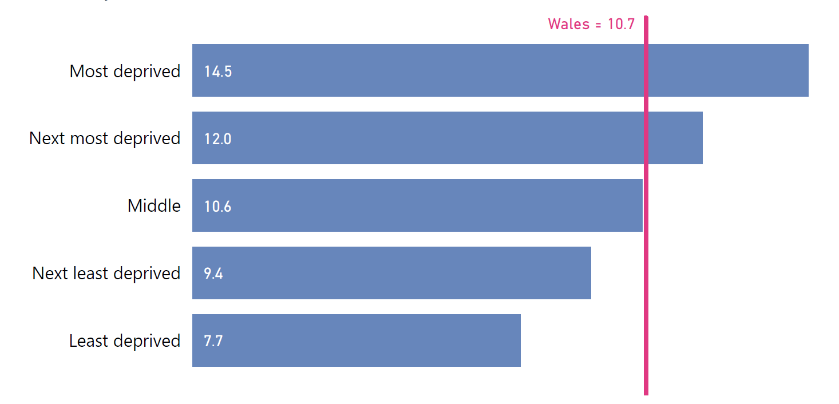
Figure 1: Proportion of all deaths attributable to smoking, persons aged 35+ by deprivation quintile, Wales, 2020-22. Source: Public Health Wales
The European Age Standardised Rate (EASR) was 190 per 100,000. The 95% Confidence Intervals (CIs) associated with this EASR were 186 to 193. The EASR is the most appropriate measure for comparison between times and places. See Appendix 1 for details on calculating the this measure.
The EASR for smoking attributable mortality in Wales in 2020-22 amongst men was 237 per 100,000 (95% CIs, 231-243). For women the EASR was 152 per 100,000 (95% CIs, 148-157). The rate for smoking attributable mortality amongst men is therefore statistically significantly higher than for women. This reflects historically higher rates of smoking prevalence amongst men.
The current EASR of 190 per 100,000 represents a decline from the figure of 217 per 100,000 for the period 2011-13. However, the average number of annual smoking attributable deaths in 2011-13 was 3,899, a difference of only 54 smoking attributable deaths per year over that period. Indeed, whilst EASR declined in most 3-year periods over the past decade, the estimated annual number of smoking attributable deaths rose in most years pre-COVID. These figures may reflect a cohort effect, with those who entered adulthood when smoking prevalence was high relative to today now reaching ages at which the harms of historic smoking are most frequently experienced. See Figure 2.
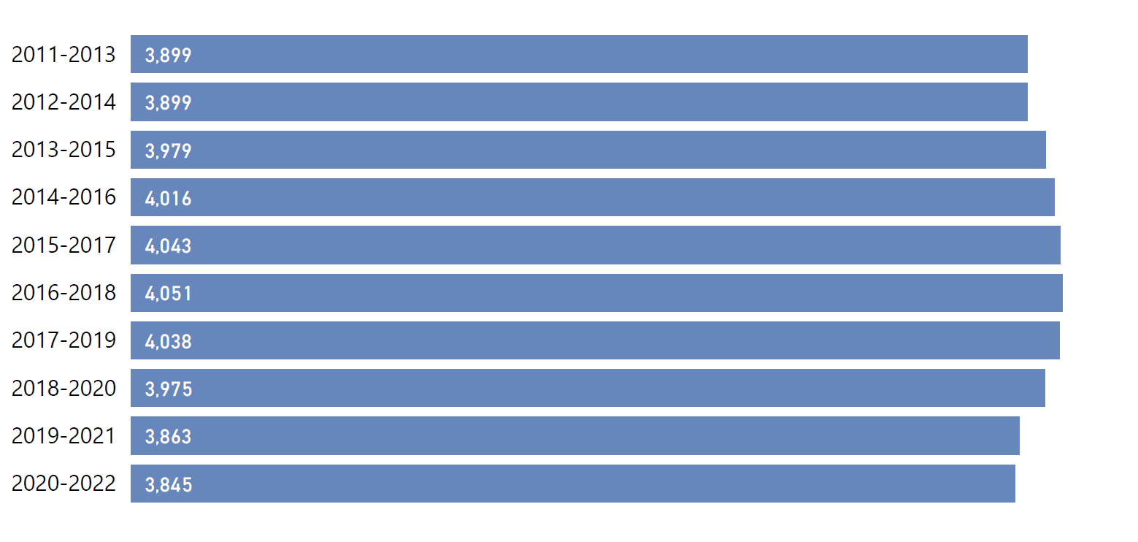
Figure 2: Smoking attributable mortality, average annual deaths, persons aged 35+, Wales, 2020-22. Source: Public Health Wales
The highest EASR for smoking attributable mortality was 220 per 100,000 seen in Cwm Taf Morgannwg UHB. The lowest was 152 seen in Powys THB. There is considerable variation between Health Boards in rates of smoking attributable mortality, with the high rates relative to Wales as a whole in Aneurin Bevan UHB and Cwm Taf Morgannwg UHB unlikely to be due to chance. See Figure 3.

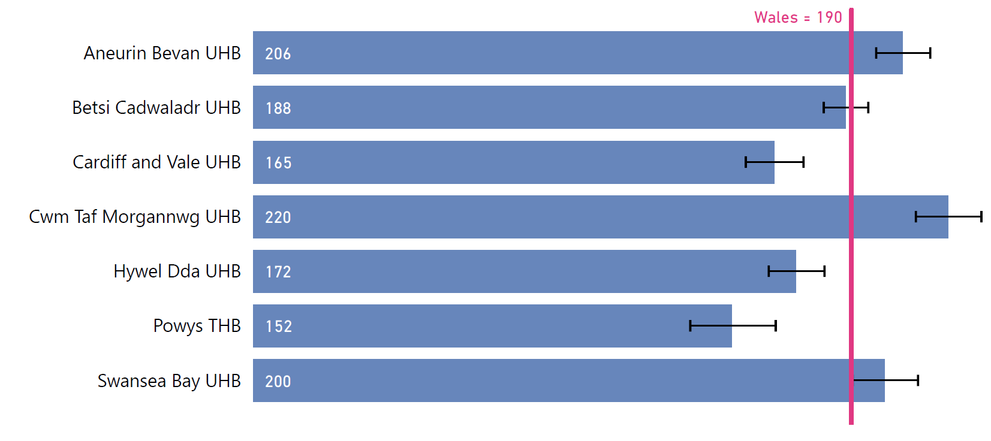
Figure 3: Smoking attributable mortality, European Age Standardised Rate (EASR), persons aged 35+ by Health Board, Wales, 2020-22. Source: Public Health Wales
Consistent with other smoking related measures such as prevalence, there was a gradient in smoking related mortality associated with deprivation. The EASR for those living in the most deprived fifth of Lower Super Output Areas (LSOAs) was 337 per 100,000 (95% CIs, 326-350) compared to the Wales EASR of 190 per 100,000 and the EASR of 111 (95% CIs, 105-116) for the least deprived fifth of LSOAs. Whilst the absolute fall in mortality amongst those in the most deprived quintile was larger than that for the least deprived in 2011-13 compared with 2020-22 (decreasing by 29 per 100,000 in the most deprived quintile compared with 18 per 100,000 in the least deprived), the relative difference increased over this time period, with the rate in the most deprived area 2.8 times higher than the least deprived in 2011-13 but 3.1 times higher in 2020-22. The EASR for smoking attributable mortality by deprivation quintile in Wales in 2020-22 is shown in Figure 4. These figures again demonstrate the impact of smoking on health inequalities.
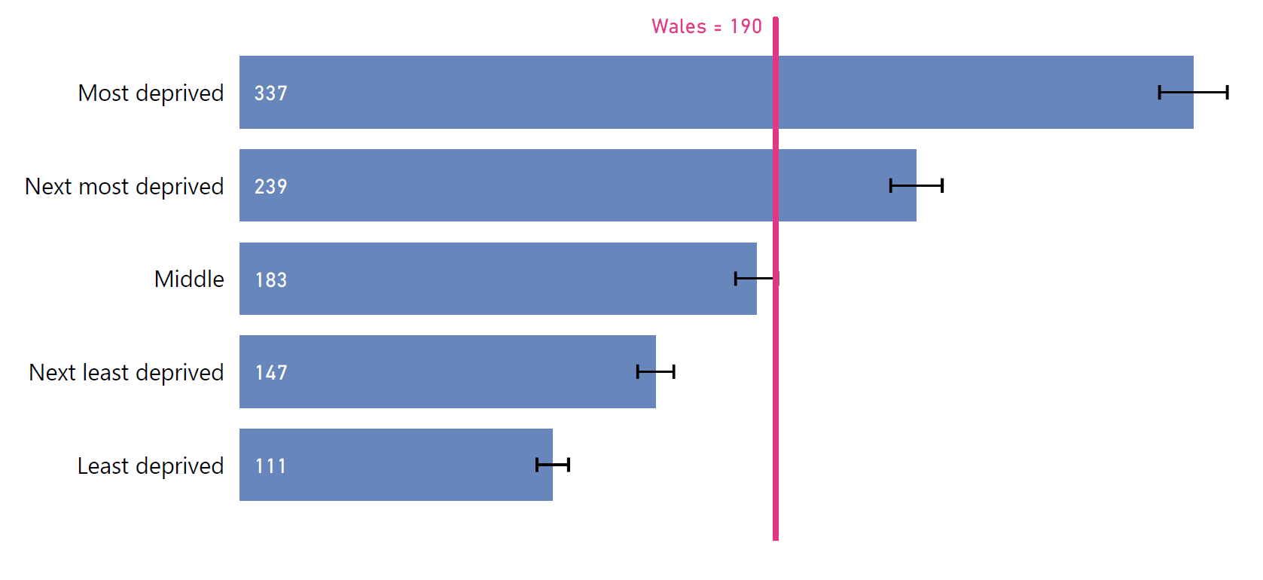
Figure 4: Smoking attributable mortality, European Age Standardised Rate (EASR), persons aged 35+ by deprivation quintile, Wales, 2020-22. Source: Public Health Wales

Smoking attributable hospital admissions in Wales, 2020-22
Over the period 2020-22, an estimated 17,195 hospital admissions per year in Wales were due to smoking. This means that on average 3.4% of all hospital admissions in Wales amongst those aged 35 and over in these years were attributable to smoking.
The crude rate of smoking attributable hospital admissions was 927 per 100,000. The European Age Standardised Rate (EASR) was 862 per 100,000. The 95% Confidence Intervals associated with this EASR were 854 to 869.
The EASR for smoking attributable hospital admissions in Wales in 2020-22 amongst men was 1,057 per 100,000 (95% CIs, 1,045-1,069). For women the EASR was 694 per 100,000 (95% CIs, 685-704).
There is considerable variation between Health Boards in rates of smoking attributable hospital admissions, with the high rates relative to Wales as a whole in Aneurin Bevan UHB, Betsi Cadwaladr UHB and Cwm Taf Morgannwg UHB unlikely to be due to chance. It is important to note that patterns of hospital admissions are likely to have been affected by COVID in different ways in different areas and that variation between areas may show different patterns in future analysis covering post-pandemic periods. See Figure 5.
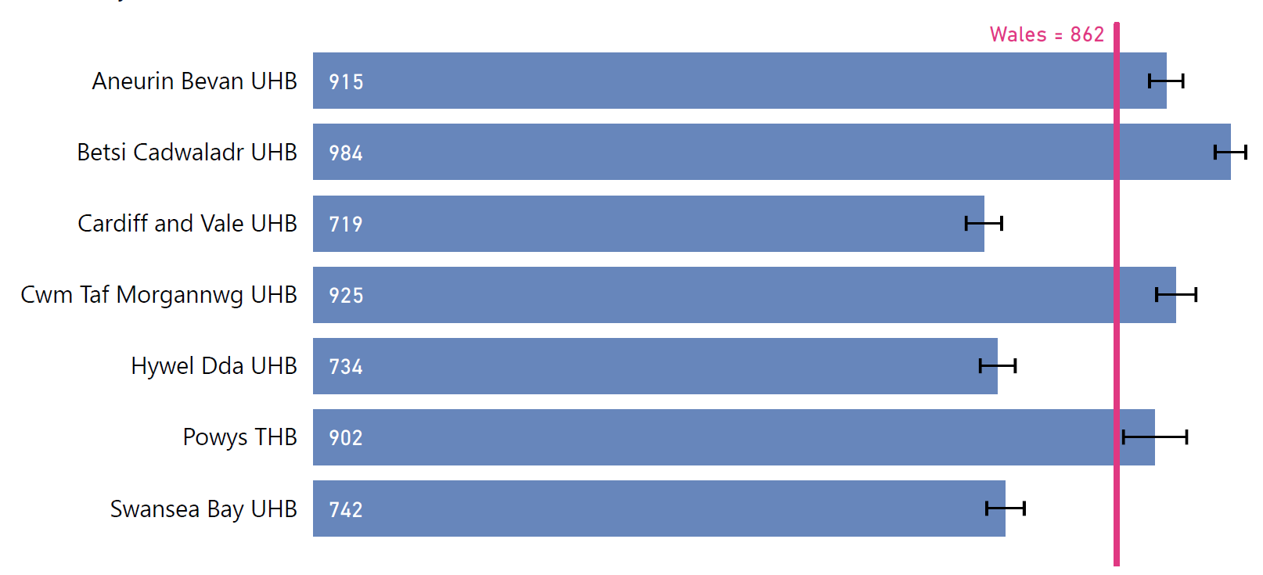
Figure 5: Smoking attributable hospital admissions, European Age Standardised Rate (EASR), persons aged 35+ by Health Board, Wales, 2020-22. Source: Public Health Wales
There was a gradient in smoking related hospital admissions associated with deprivation. The EASR for those living in the most deprived fifth of Lower Super Output Areas (LSOAs) was 1,416 per 100,000 (95% CIs, 1,392-1,440) compared to the EASR for all of Wales of 862 per 100,000 and was 2.7 times higher than the EASR of 527 (95% CIs, 696-725) in the least deprived fifth of LSOAs. See Figure 6.
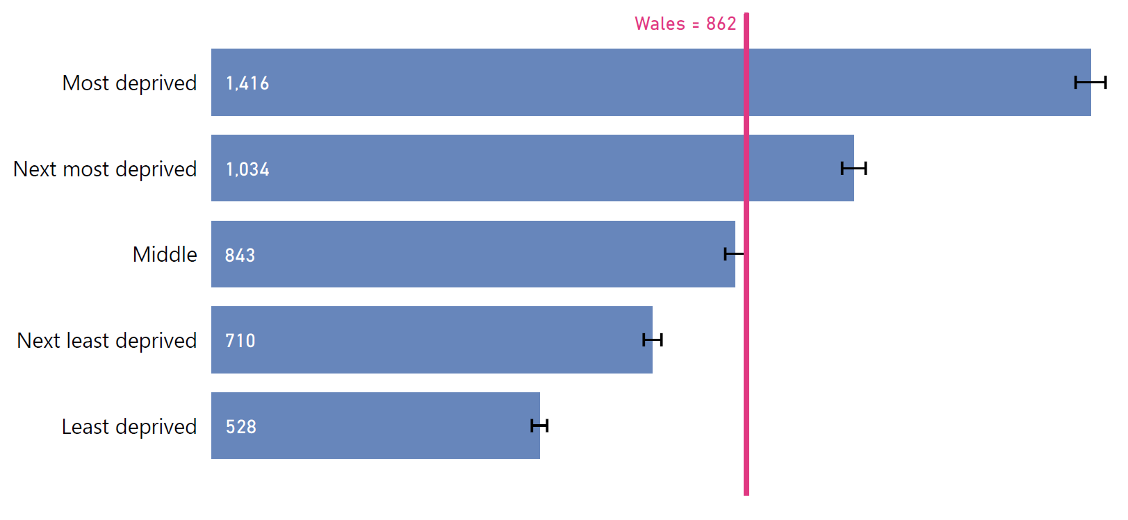
Figure 6: Smoking attributable admissions, European Age Standardised Rate (EASR), persons aged 35+ by deprivation quintile, Wales, 2020-22. Source: Public Health Wales

Appendix 1: Technical details related to calculation of smoking attributable mortality and hospital admissions in Wales

Sources of data

Numerator (mortality) | Public Health Mortality (PHM), Office for National Statistics (ONS)
Numerator (admissions) | Patient Episode database for Wales (PEDW), Digital Health and Care Wales (DHCW)
Denominator | Mid-year population estimates, ONS
Smoking prevalence | Annual Population Survey (APS), ONS
Relative risks: | Public Health England (PHE, now called Office for Health Improvement and Disparities, OHID)
Deprivation | Welsh Index of Multiple Deprivation 2019, Welsh Government (WG)  Note that for the production of rates by WIMD fifth, we have used the 2020 ONS population estimates as a proxy for 2021 and 2022. This is because ONS have not yet released the new Lower Super Output Area population estimates following Census 2021.

Additional notes on data and calculations used in this report
Smoker and ex-smoker prevalence was calculated using Annual Population Survey (APS) data for the period 2020-2022. The prevalence data was then applied to the smoking-attributable risk ratios to produce the smoking-attributable fractions. These fractions were used to estimate the number of hospital admissions attributable to smoking in all periods. Given that smoking prevalence in Wales has fallen between 2011-13 and 2020-22, this method is likely to underestimate smoking-attributable hospital admissions in the earlier periods, when smoking prevalence was higher.
Small numbers of respondents were found within the APS, especially in the older age groups (aged 80-84, 85-89 and 90+). To make the APS data more robust for analysis, we calculated smoking prevalence using 10-year age bands instead of 5-year age bands, e.g. 25-34, 35-44 as opposed to 25-29, 30-34, 35-39, 40-44, and we combined the 75-79, 80-84, 85-89 and 90+ age bands into a single 75+ age band. Nevertheless, there are still single-figure counts of smokers in some age groups in the smaller health boards. Given the resulting potential for random variation in smoking prevalence estimates calculated using the APS, the health board figures should be interpreted with caution, especially for smaller health boards such as Powys THB. It should also be noted the answer to the smoking question is missing for around 3% of APS respondents. is a limitation with the population attributable fraction methodology associated with the time lag between smoking and the occurrence of smoking-related harms. This work is based on relative risks and uses current distributions of smoking and therefore assumes that there is no time lag between exposure and outcome; this is unlikely to be the case.
95% Confidence Intervals have been calculated according to the method proposed by Dobson et al (1991): Dobson A.J. et al (1991) Confidence intervals for weighted sums of Poisson parameters. Stat Med 10(3):457-462.
The European Age Standardised Rate (EASR) provides a measure of incidence that allows for more meaningful comparison between different time periods and geographies. The numbers of deaths or hospital admissions per 100 000 population are influenced by the age distribution of the population. Two populations with the same age-specific mortality rates for a particular cause of death will have different overall death rates if the age distributions of their populations are different. Age-standardized mortality rates adjust for differences in the age distribution of the population by applying the observed age-specific mortality rates for each population to a standard population.

Public Health England, ‘Consultation on Proposed Changes to the Calculation of Smoking-Attributable Mortality and Hospital Admissions’ (London: Public Health England, September 2020), https://assets.publishing.service.gov.uk/media/5f60618cd3bf7f723d08beb6/Consultation-Proposed_changes_to_smoking_relative_risks.pdf.
Note that it would be incorrect to state that "an estimated 3,845 people per year died from smoking". The method used did not attribute any person's death entirely to smoking; rather, for each disease specified, a proportion of deaths was considered to be caused by smoking. For example, if 50% of deaths from stomach or duodenal ulcers in men aged 65-69 were considered to be attributable to smoking, and 13 men in this age group died from this condition, it would not make sense to say that 6.5 of these men died from smoking. Rather, in this case, 6.5 deaths would be added to the overall number of smoking-attributable deaths.
See Appendix 1 for notes on interpreting figures for smaller Health Boards
Office for National Statistics (ONS), ‘Smoking Habits in the UK and Its Constituent Countries’, Adult Smoking Habits in the UK (Office for National Statistics, 6 September 2023), https://www.ons.gov.uk/peoplepopulationandcommunity/healthandsocialcare/healthandlifeexpectancies/bulletins/adultsmokinghabitsingreatbritain/2022
Lower Super Output Areas (LSOAs) are areas of approximately 1,500 residents. There are 1,909 in Wales. The Welsh Index of Multiple Deprivation ranks each area on the basis of a range of measures and classifies them into quintiles. See https://wimd.gov.wales/ for more details
Note that it would be incorrect to state that "an estimated 17,179 people per year were admitted to hospital due to smoking" during that time. The method used did not attribute any person's hospital admission entirely to smoking; rather, for each disease specified, a proportion of admissions was considered to be caused by smoking.
See Appendix 1 for notes on interpreting figures for smaller Health Boards
Eurostat, Revision of the European Standard Population: Report of Eurostat’s Task Force (Luxembourg: European Union, 2013), https://ec.europa.eu/eurostat/documents/3859598/5926869/KS-RA-13-028-EN.PDF.pdf/e713fa79-1add-44e8-b23d-5e8fa09b3f8f?t=1414782757000.

