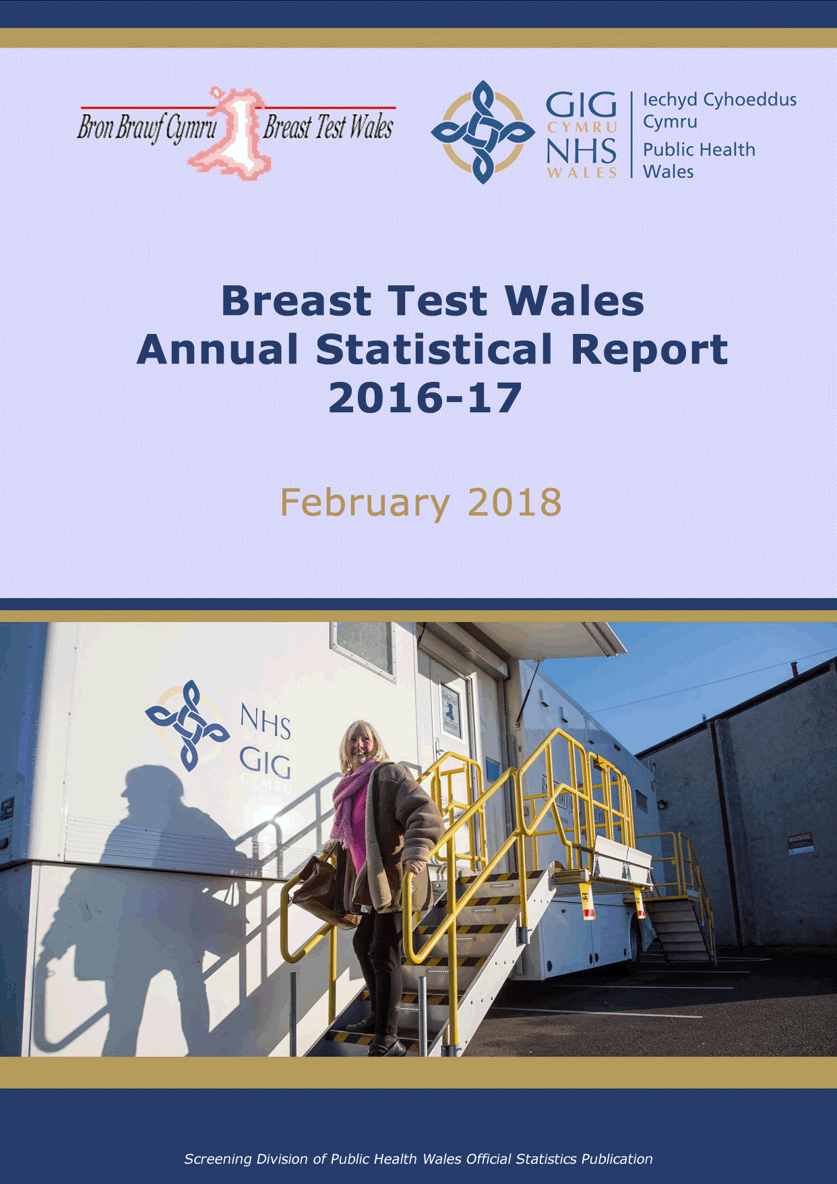
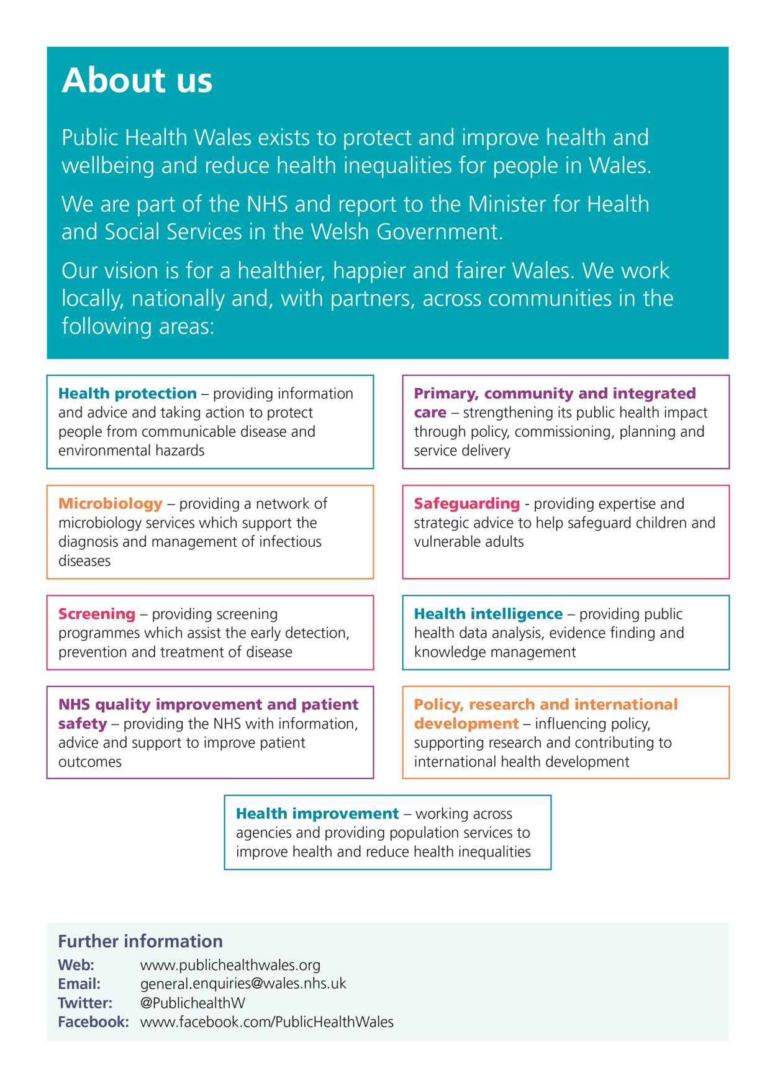
This report is a detailed summary of information on work undertaken by the Welsh Breast Screening Programme for the year April 2016 to the end of March 2017.

Publication Details
Title: Breast Test Wales Annual Statistical Report 2016-17
Date: This report published 22 February 2018
ISBN: 978-1-910768-48-8

For more information about this report contact:
Helen Clayton, Lead Informatics and Data Services Manager,
Informatics Division, Floor 6, Public Health Wales, Number 2 Capital Quarter, Tyndall Street, Cardiff, CF10 4BZ
Tel: 029 2010 4405

Email: Screening.Information@wales.nhs.uk
Quality Assurance Statement
Screening data records are constantly updated. The databases used by Public Health Wales Screening Division are updated on a daily basis when records are added, changed or removed (archived). This might relate to when a person has been identified as needing screening; has had screening results that need to be recorded, or has a change of status and no longer needs screening respectively. Data is received from a large number of different sources with varying levels of accuracy and completeness. The Screening Division checks data for accuracy by comparing datasets – for example GP practice data – and corrects the coding data where possible. It should be noted that there are sometimes delays in data collection – for example a person might not immediately register with their GP if they move address. These delays will therefore affect the completeness of the data depending on individual circumstances. In addition, the reader should be aware that data is constantly updated and there might be slight readjustments in the numbers cited in this document year on year because of data refreshing.

© 2018 Public Health Wales NHS Trust
Material contained in this document may be reproduced without prior permission provided it is done so accurately and is not used in a misleading context.
Acknowledgement to Public Health Wales NHS Trust to be stated.
Copyright in the typographical arrangement, design and layout belongs to Public Health Wales NHS Trust
Contents

1 Introduction 6
1.1 ‘Key messages’ for women 6
1.2 Programme delivery 7
1.3 Screening pathway 7
2 Headline Statistics 8
3 Data 9
3.1 Coverage 9
3.2 Screening Activity 10
3.3 Invitation and Uptake 11
3.4 Assessment 14
3.4.1 Referral for assessment 14
3.4.2 Assessment biopsy procedures 15
3.5 Cancer Detection 16
3.5.1 Cancer detection rate 16
3.5.2 Cancer type and size 19
4 Definitions 22
5 Editorial Team and Pre-Release List 23

Tables and Graphs
Graph 1: Breast screening coverage %, women aged 53-70, by Health Board of residence, 2015-2017…………………………………………………………………10
Graph 2: 10-year screening activity, all ages, 2007-08 to 2016-17……..11
Graph 3: 10-year uptake % of routine breast screening invitations, aged 50-70, 2007-08 to 2016-17………………………………………………………………………12
Graph 4: Uptake % by invite type, aged 50-70, 2014-15 to 2016-17….13
Graph 5: Uptake % by screening unit, aged 50-70, 2014-15 to 2016-17……………………………………………………………………………………………………………….14
Table 1: Referral for assessment, all ages, by invite/referral type, 2014-15 to 2016-17…………………………………………………………………………………………….15
Table 2: Referral for assessment biopsy procedures, all ages, by invite/referral type, 2014-15 to 2016-17…………………………………………………16
Table 3: Cancer detection rate (per 1000 screened), all ages, by invite/referral type, 2014-15 to 2016-17…………………………………………………17
Graph 6: Cancer detection rate per 1000 screened, by invite type, by screening unit, 2014-15 to 2016-17………………………………………………….….…18
Graph 7: Cancer detection rate (per 1000 screened), 2007-08 to 2016-17, by age group…………………………………………………………………………………..…..19
Table 4: Invasive cancers detected, all ages, by invite/referral type, 2014-15 to 2016-17……………………………………………………………………………..…..20
Table 5: Size of invasive cancers detected, all ages, by invite/referral type, 2014-15 to 2016-17…………………………………………………………………………20
Table 6: Non-invasive/micro-invasive cancers detected, all ages, by invite/referral type, 2014-15 to 2016-17…………………………………………………21

Introduction
The aim of the breast screening programme is to reduce mortality from breast cancer. Women aged 50 to 70 who are resident in Wales and registered with a General Practitioner are invited for a mammogram (X-ray of the breasts) every three years.

Breast Test Wales is divided into three geographical divisions with centres in Cardiff, Swansea, Llandudno and Wrexham. Ten mobile units work across Wales to provide local screening to women who live some distance from a centre, visiting over 100 sites in every three year round of screening.

‘Key messages’ for women

- Breast screening reduces your risk of dying from breast cancer.
- Women aged 50 to 70 are invited for a breast X-ray every three years. Women over the age of 70 are not routinely invited as there is no evidence of a reduction in mortality from screening women in this age range.
- Screening can find cancers when they are too small to see or feel. Finding and treating cancer early gives you the best chance of survival.
- Breast screening is a free NHS test that is carried out at screening centres and accessible mobile units across Wales.
- If you notice a change in your breasts, visit your GP immediately.
- Screening will miss some cancers, and some cancers cannot be cured.
- Taking part in breast screening is your choice. Read the information leaflet carefully to help you make your decision.

Programme delivery

The Screening Division of Public Health Wales is responsible for managing, delivering and quality assuring the breast screening programme in Wales. Breast Test Wales employs a Head of Programme, Quality Assurance (QA) Surgeon, QA Radiologist, QA Pathologist and All-Wales Administration Coordinator with support from a secretarial and administration team.
Women aged 50- 70 who are resident in Wales and registered with a GP are offered screening at either a mobile unit in their locality or at one of the centres in Llandudno, Wrexham, Swansea or Cardiff.

Screening pathway

Women aged between 50 and 70 are invited for breast screening every three years. Not all women receive their first invitation in the year they reach 50 because the process depends on the GP surgery of registration. However, Breast Test Wales will invite all women for breast screening before their 53rd birthday.
Women aged between 50 and 70 who are being followed up at a hospital breast clinic will still receive an invitation from Breast Test Wales.
Women over the age of 70 are not routinely invited as there is no evidence of a reduction in mortality from screening women in this age range.
Women who attend for screening have a mammogram (X-ray of their breasts). If there are any abnormalities observed on the mammogram the woman is invited to an assessment clinic for further tests.
More information about the programme and copies of previous statistical reports are available at www.breasttestwales.wales.nhs.uk

Headline Statistics

This report covers activity in the period April 2016 to March 2017. All comparative annual data relates to financial years.
- Coverage: this is defined as the percentage of women resident and eligible for breast screening at a particular point in time who have been screened within the previous 3 years. As at 31st March 2017 coverage of women aged 53-70 was 73.6%, compared with 74.1% at the same point in 2016 and 71.2% in 2015.
- Screening activity: nearly 123,000 women aged 49 and over were screened in 2016-17, compared with 115,000 last year.
- Invitation and uptake: in 2016-17 more than 157,000 women aged 50-70 were invited for screening, compared to 144,000 last year. The uptake of screening for this group was 70.4%, compared to 70.9% in 2015-16 and 72.1% in 2014-15.
- Assessment: Referrals for assessment were 5.3% of those screened in 2016-17. This compares to 5.4% last year and 5.4% in 2014-15.
- Cancer detection: a total of 1185 cancers were detected in women screened aged 49 and over. This represents 9.6 cases per 1000 women screened. In comparison, there were 1166 cancers detected in 2015-16 (10.1 per 1000 screened) and 1207 detected in 2014-15 (10.6 per 1000 screened).
- Of the 1185 cancers detected this year, 77.8% (922) were invasive lesions. In 2015-16 80.8% (942) were invasive and in 2014-15 79.0% (954).
- In 2016-17 49.1% (453) of the invasive cancers detected were classified as small (less than 15mm in size). This compares to 52.9% (498) in 2015-16 and 53.5% (510) in 2014-15.

Data

Coverage

Coverage is defined as the percentage of women resident and eligible for breast screening at a particular point in time who have been screened within the previous 3 years. Ineligible women include those who have undergone bilateral mastectomy.
Both uptake and round length can affect coverage. To allow all women time to have received their first invitation, the coverage is presented for the 53-70 age range. As at 31st March 2017 coverage of women aged 53-70 was 73.6%, compared with 74.1% at the same point in 2016 and 71.2% in 2015.
Considerable work has been undertaken in recent years to ensure the round length delay resulting when the service modernised to digital mammography has been corrected. The round length relates to invitations issued within 36 months of previous screen. Coverage has now reached above the 70% standard for all Health Boards (Graph 1).

Graph 1: Breast screening coverage percentage (%), women aged 53-70, by Health Board of residence, 2015-2017
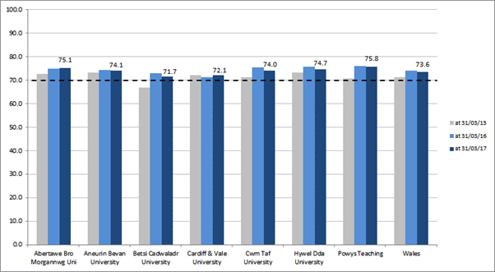

Screening Activity

Women are routinely invited to attend breast screening if they are aged between 50 and 70 (or aged 49 if they are 50 in the year their practice is screened). Screening activity numbers also include women older than 70 who have contacted the service to request screening. It is important to note there is no evidence that routine screening saves lives in this older age group. All women who notice a change in their breasts should contact their GP immediately.
In total, nearly 123,000 women aged 49 and over were screened in 2016-17. The programme continues at full capacity following the two years of disruption associated with digital implementation. Graph 2 illustrates the general trend of increasing screening numbers over the financial years.

Graph 2: 10-year total screening activity, all ages, 2007-08 to 2016-17
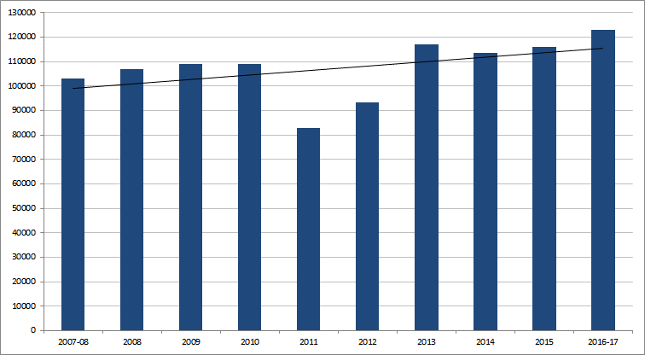

Invitation and Uptake

The minimum standard for uptake of a routine invitation in those aged 50-70 has been set at 70%. With the exception of financial years 2013 and 2014, Breast Test Wales has observed a gradual decline in uptake since 2009.
In 2016-17 uptake reduced to 70.4%, compared to 70.9% in 2015-16 and 72.1% in 2014-15. Graph 3 shows uptake of screening amongst the routinely invited population.
(Note: The 2016-17 Screening Division Annual Report describes breast screening uptake as 73.1%. This refers to an entire 3 year screening round as at November 2017, while figures here relate to women invited in 2016-17 only.)

Graph 3: 10-year uptake percentage (%) of routine breast screening invitations, aged 50-70, 2007-08 to 2016-17
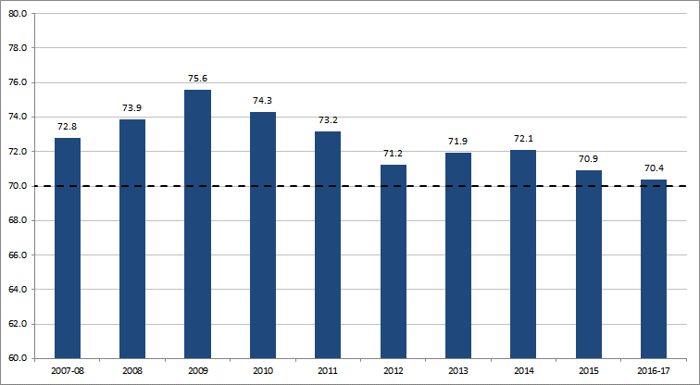

Uptake can vary according to the type of invitation. Routine invitations can be sub-divided into the following groups:
- First invitation
- Invitation to a previous non-attender
- Invitation to a previous attender who has been screened within the last 5 years
- Invitation to a previous attender who has been screened more than 5 years ago

As Graph 4 demonstrates, uptake is highest among the regular attendees (86.3%) and lowest among non-attenders (15.7%). Breast Test Wales is currently working to explore barriers to screening in eligible women.

Graph 4: Uptake percentage (%) by invite type, aged 50-70, 2014-15 to 2016-17
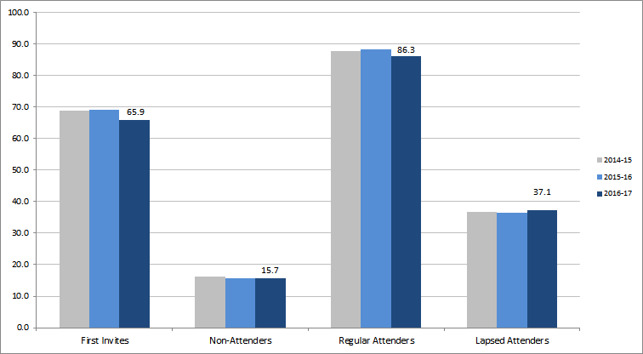

In terms of regional effect, uptake is marginally highest in South East Wales in 2016-17 (Graph 5). The North and South West regions both saw a fall compared to the previous year, with the former dipping below the minimum standard for the first time.

Graph 5: Uptake percentage (%) by screening unit, aged 50-70, 2014-15 to 2016-17
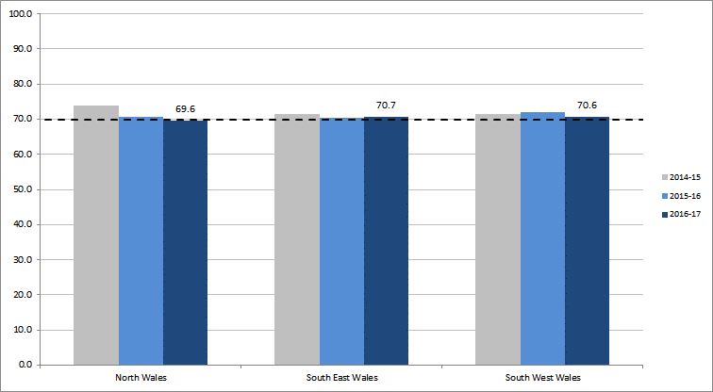

Assessment

Referral for assessment

If any abnormalities suggestive of cancer are observed on the screening mammogram, the woman will be recalled to an assessment clinic for further assessment tests. It is expected that more women are recalled to assessment following their first screen (the prevalent screen) as there are no prior images to inform the recall decision.
Referral rates for women who have been screened previously (the incident screen) are likely to be lower because they will present with more recent disease and the screening history can assist the image reader (Table 1).

Table 1: Referral for assessment, all ages, by invite/referral type, 2014-15 to 2016-17
 | 2014-15 |  |  | 2015-16 |  |  | 2016-17
 | Screen | Refer | % | Screen | Refer | % | Screen | Refer | %
Total | 113,365 | 6177 | 5.4 | 115,794 | 6279 | 5.4 | 122,903* | 6458* | 5.3
Prevalent Screen | 19,874 | 1899 | 9.6 | 20,309 | 1968 | 9.7 | 20,590 | 1931 | 9.4
Incident Screen | 83,568 | 3627 | 4.3 | 84,803 | 3618 | 4.3 | 92,695 | 3943 | 4.3
First invite for routine screening | 17,223 | 1663 | 9.7 | 17,424 | 1647 | 9.5 | 17,495 | 1637 | 9.4
Routine invite to previous non-attenders | 2651 | 236 | 8.9 | 2885 | 321 | 11.1 | 3095 | 294 | 9.5
Routine invite to previous attenders, last screen within 5 years | 78,961 | 3349 | 4.2 | 79,550 | 3277 | 4.1 | 87,862 | 3643 | 4.1
Routine invite to previous attenders, last screen more than 5 years previously | 4607 | 278 | 6.0 | 5253 | 341 | 6.5 | 4833 | 300 | 6.2
Early recalls | 73 | 73 | 100 | 73 | 73 | 100 | 69 | 69 | 100
Self/GP referrals | 9850 | 578 | 5.9 | 10,609 | 620 | 5.8 | 9471 | 510 | 5.4
* Total includes High risk invite type

Assessment biopsy procedures

As part of the assessment process further mammograms and a breast examination is undertaken. If following these further tests and an ultrasound scan, there remains a concern there is a cancer then a biopsy procedure is required to make a diagnosis. Most biopsies are carried out in assessment clinic and use wide bore needle technique. A small number of women require an open surgical biopsy to achieve a definitive diagnosis. A very small number of fine needle aspirations of the breast are performed each year but this is normally in addition to obtaining a tissue sample. The needle procedures are mostly conducted at a Breast Test Wales unit while an open biopsy is a surgical operation which requires a hospital visit. Of the 6458 women referred for assessment in 2016-17, 38.7% (2502) underwent fine needle aspiration and/or wide bore needle, while 2.2% (140) required an open biopsy (Table 2).

Table 2: Referral for assessment biopsy procedures, all ages, by invite/referral type, 2014-15 to 2016-17
 | 2014-15 |  |  |  |  | 2015-16 |  |  |  |  | 2016-17
 | Refer | Needle Bx | % | Open Bx | % | Refer | Needle Bx | % | Open Bx | % | Refer | Needle Bx | % | Open Bx | %
Total | 6177 | 2549 | 41.3 | 153 | 2.5 | 6279 | 2503 | 39.9 | 149 | 2.4 | 6458* | 2502* | 38.7 | 140 | 2.2
Prevalent Screen | 1899 | 820 | 43.2 | 79 | 4.2 | 1968 | 820 | 41.7 | 68 | 3.5 | 1931 | 737 | 38.2 | 64 | 3.3
Incident Screen | 3627 | 1457 | 40.2 | 66 | 1.8 | 3618 | 1404 | 38.8 | 66 | 1.8 | 3943 | 1515 | 38.4 | 70 | 1.8
First invite for routine screening | 1663 | 712 | 42.8 | 72 | 4.3 | 1647 | 690 | 41.9 | 58 | 3.5 | 1637 | 620 | 37.9 | 57 | 3.5
Routine invite to previous non-attenders | 236 | 108 | 45.8 | 7 | 3.0 | 321 | 130 | 40.5 | 10 | 3.1 | 294 | 117 | 39.8 | 7 | 2.4
Routine invite to previous attenders, last screen within 5 years | 3349 | 1345 | 40.2 | 64 | 1.9 | 3277 | 1247 | 38.1 | 60 | 1.8 | 3643 | 1377 | 37.8 | 62 | 1.7
Routine invite to previous attenders, last screen more than 5 years previously | 278 | 112 | 40.3 | 2 | 0.7 | 341 | 157 | 46.0 | 6 | 1.8 | 300 | 138 | 46.0 | 8 | 2.7
Early recalls | 73 | 5 | 6.8 | 0 | 0 | 73 | 4 | 5.5 | 2 | 2.7 | 69 | 5 | 7.2 | 0 | 0
Self/GP referrals | 578 | 267 | 46.2 | 8 | 1.4 | 620 | 275 | 44.4 | 13 | 2.1 | 510 | 242 | 47.5 | 6 | 1.2
* Total includes High risk invite type

Cancer Detection

Cancer detection rate

A total of 1185 cancers were detected in women screened aged 49 and over during the period April 2016 to March 2017. This represents 9.6 cases per 1000 women screened. In comparison, there were 1166 cancers detected in 2015-16 (10.1 per 1000 screened) and 1207 detected in 2014-15 (10.6 per 1000 screened).
Cancer detection amongst prevalent screen women was 8.6 per 1000 screened, compared to 9.8 per 1000 in 2015-16 and 10.4 per 1000 in 2014-15. For incident screen women the rate was 9.2 per 1000 screened in 2016-17, 9.4 in 2015-16 and 10.0 in 2014-15 (Table 3).

Table 3: Cancer detection rate (per 1000 screened), all ages, by invite/referral type, 2014-15 to 2016-17
 | 2014-15 |  |  | 2015-16 |  |  | 2016-17
 | Screened | Cancers | Rate | Screened | Cancers | Rate | Screened | Cancers | Rate
Total | 113,365 | 1207 | 10.6 | 115,794 | 1166 | 10.1 | 122,903* | 1185 | 9.6
Prevalent Screen | 19,874 | 207 | 10.4 | 20,309 | 200 | 9.8 | 20,590 | 178 | 8.6
Incident Screen | 83,568 | 837 | 10.0 | 84,803 | 795 | 9.4 | 92,695 | 849 | 9.2
First invite for routine screening | 17,223 | 177 | 10.3 | 17,424 | 163 | 9.4 | 17,495 | 143 | 8.2
Routine invite to previous non-attenders | 2651 | 30 | 11.3 | 2885 | 37 | 12.8 | 3095 | 35 | 11.3
Routine invite to previous attenders, last screen within 5 years | 78,961 | 773 | 9.8 | 79,550 | 715 | 9.0 | 87,862 | 774 | 8.8
Routine invite to previous attenders, last screen more than 5 years previously | 4607 | 64 | 13.9 | 5253 | 80 | 15.2 | 4833 | 75 | 15.5
Early recalls | 73 | 0 | 0 | 73 | 0 | 0 | 69 | 0 | 0
Self/GP referrals | 9850 | 163 | 16.5 | 10,609 | 171 | 16.1 | 9471 | 158 | 16.7
* Total includes High risk invite type

Examination of cancer detection rates at screening unit level (Graph 6) shows overall decreases for the North and South East regions but a rise in South West Wales.

Graph 6: Cancer detection rate per 1000 screened, by invite type, by screening unit, 2014-15 to 2016-17
Total | Prevalent Screen | Incident Screen
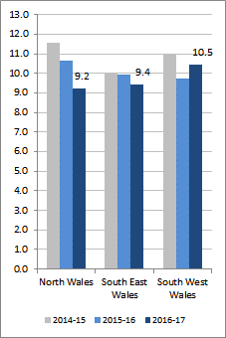 | 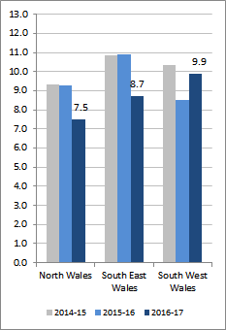 | 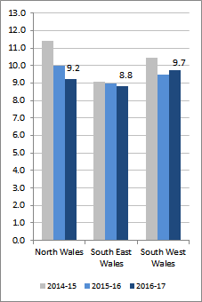

Graph 7 plots cancer detection rates over a 10 year period and shows how breast cancer incidence generally increases with age. In 2016-17 the cancer detection rate for women aged 50-54 was 8.0 per 1000 screened, rising to 10.3 per 1000 for those aged 60-64 and 11.4 per 1000 in the 65-70 age group.

Graph 7: Cancer detection rate (per 1000 screened), 2007-08 to 2016-17, by age group
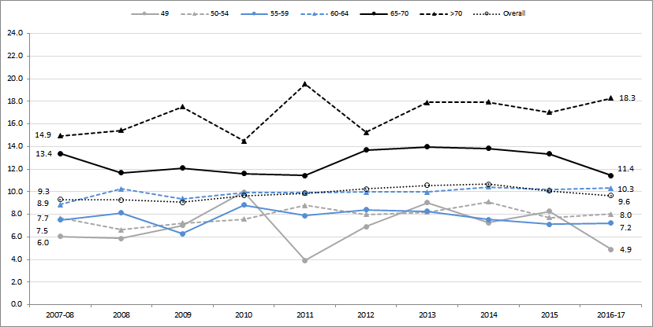

Cancer type and size

The breast cancers identified are described in two groups.
An invasive cancer is one which has spread into surrounding, healthy breast tissue. A non-invasive or micro-invasive cancer is contained within the ducts and lobules of the breast or may have started to spread but only by a very small amount (less than 1mm).
In 2016-17 77.8% of the cancers detected in women screened were invasive, compared to 80.8% in 2015-16 and 79.0% in 2014-15 (Table 4). The invasive cancers that are generally too small to feel (less than 15mm) accounted for 49.1% of all the invasives detected in 2016-17 (Table 5). This compares to 52.9% last year and 53.5% in 2014-15.
Non-invasive or micro-invasive disease made up 22.2% of all cancers detected in 2016-17, while in 2015-16 they accounted for 19.2% and in 2014-15 20.1% (Table 6).

Table 4: Invasive cancers detected, all ages, by invite/referral type, 2014-15 to 2016-17
 | 2014-15 |  |  | 2015-16 |  |  | 2016-17
 | Cancers | Invasive | % | Cancers | Invasive | % | Cancers | Invasive | %
Total | 1207 | 954 | 79.0 | 1166 | 942 | 80.8 | 1185 | 922 | 77.8
Prevalent Screen | 207 | 142 | 68.6 | 200 | 144 | 72.0 | 178 | 131 | 73.6
Incident Screen | 837 | 679 | 81.1 | 795 | 657 | 82.6 | 849 | 671 | 79.0
First invite for routine screening | 177 | 121 | 68.4 | 163 | 113 | 69.3 | 143 | 102 | 71.3
Routine invite to previous non-attenders | 30 | 21 | 70 | 37 | 31 | 83.8 | 35 | 29 | 82.9
Routine invite to previous attenders, last screen within 5 years | 773 | 628 | 81.2 | 715 | 587 | 82.1 | 774 | 609 | 78.7
Routine invite to previous attenders, last screen more than 5 years previously | 64 | 51 | 79.7 | 80 | 70 | 87.5 | 75 | 62 | 82.7
Early recalls | 0 | 0 | 0 | 0 | 0 | 0 | 0 | 0 | 0
Self/GP referrals | 163 | 133 | 81.6 | 171 | 141 | 82.5 | 158 | 120 | 75.9

Table 5: Size of invasive cancers detected, all ages, by invite/referral type, 2014-15 to 2016-17
 | 2014-15 |  |  |  |  | 2015-16 |  |  |  |  | 2016-17
 | Total inv | <15 mm | % | 15+ mm | % | Total inv | <15 mm | % | 15+ mm | % | Total inv | <15 mm | % | 15+ mm | %
Total | 954 | 510 | 53.5 | 402 | 42.1 | 942 | 498 | 52.9 | 409 | 43.4 | 922 | 453 | 49.1 | 437 | 47.4
Prevalent Screen | 142 | 69 | 48.6 | 67 | 47.2 | 144 | 77 | 53.5 | 64 | 44.4 | 131 | 62 | 47.3 | 64 | 48.8
Incident Screen | 679 | 377 | 55.5 | 279 | 41.1 | 657 | 353 | 53.7 | 281 | 42.8 | 671 | 343 | 51.1 | 307 | 45.7
First invite for routine screening | 121 | 58 | 47.9 | 58 | 47.9 | 113 | 58 | 51.3 | 52 | 46.0 | 102 | 49 | 48.0 | 48 | 47.1
Routine invite to previous non-attenders | 21 | 11 | 52.4 | 9 | 42.9 | 31 | 19 | 61.3 | 12 | 38.7 | 29 | 13 | 44.8 | 16 | 55.2
Routine invite to previous attenders, last screen within 5 years | 628 | 352 | 56.1 | 256 | 40.8 | 587 | 324 | 55.2 | 245 | 41.7 | 609 | 319 | 52.4 | 272 | 44.7

Table 5 (cont…)
 | 2014-15 |  |  |  |  | 2015-16 |  |  |  |  | 2016-17
 | Total inv | <15 mm | % | 15+ mm | % | Total inv | <15 mm | % | 15+ mm | % | Total inv | <15 mm | % | 15+ mm | %
Routine invite to previous attenders, last screen more than 5 years previously | 51 | 25 | 49 | 23 | 45.1 | 70 | 29 | 41.4 | 36 | 51.4 | 62 | 24 | 38.7 | 35 | 56.4
Early recalls | 0 | 0 | 0 | 0 | 0 | 0 | 0 | 0 | 0 | 0 | 0 | 0 | 0 | 0 | 0
Self/GP referrals | 133 | 64 | 48.1 | 56 | 42.1 | 141 | 68 | 48.2 | 64 | 45.4 | 120 | 48 | 40.0 | 66 | 55.0

Table 6: Non-invasive/micro invasive cancers detected, all ages, by invite/referral type, 2014-15 to 2016-17
 | 2014-15 |  |  | 2015-16 |  |  | 2016-17
 | Cancers | Non-invasive or microinv | % | Cancers | Non-invasive or microinv | % | Cancers | Non-invasive or microinv | %
Total | 1207 | 253 | 20.1 | 1166 | 224 | 19.2 | 1185 | 263 | 22.2
Prevalent Screen | 207 | 65 | 31.4 | 200 | 56 | 28.0 | 178 | 47 | 26.4
Incident Screen | 837 | 158 | 18.9 | 795 | 138 | 17.4 | 849 | 178 | 21.0
First invite for routine screening | 177 | 56 | 31.6 | 163 | 50 | 30.7 | 143 | 41 | 28.7
Routine invite to previous non-attenders | 30 | 9 | 30 | 37 | 6 | 16.2 | 35 | 6 | 17.1
Routine invite to previous attenders, last screen within 5 years | 773 | 145 | 18.8 | 715 | 128 | 17.9 | 774 | 165 | 21.3
Routine invite to previous attenders, last screen more than 5 years previously | 64 | 13 | 20.3 | 80 | 10 | 12.5 | 75 | 13 | 17.3
Early recalls | 0 | 0 | 0 | 0 | 0 | 0 | 0 | 0 | 0
Self/GP referrals | 163 | 30 | 18.4 | 171 | 30 | 17.5 | 158 | 38 | 24.0

Definitions

Coverage
The percentage of women resident and eligible for breast screening at a particular point in time, who have been screened within the previous 3 years.

Health Board
The health board of residence.

Uptake
The percentage of women routinely invited for breast screening who take up their invitation and are screened within 6 months.

Editorial Team and Pre-Release List

Editorial Team:
Dean Phillips Head of Breast Test Wales
Dr Sikha de Souza Consultant in Public Health
Dr Sharon Hillier Acting Director of Screening Division
Heather Lewis Consultant in Public Health
Helen Clayton Lead Informatics and Data Services Manager
Guy Stevens Deputy Informatics and Data Services Manager
Claire Ellis Information Officer

Pre-Release List:
These Official Statistics were sent to the people on this pre-release list five working days prior to publication in accordance with the Pre-publication Official Statistics Order Access (Wales) 2009.

Public Health Wales
Jan Williams Chair
Dr Tracey Cooper Chief Executive
Dr Quentin Sandifer Executive Director of Public Health Services and Medical Director
Anna Ashman Communications Manager, Public Health Wales

Welsh Government
Dr Frank Atherton Chief Medical Officer
Dr Andrew Goodall Director General - Health and Social Services
Irfon Rees Deputy Director - Public Health Division
Stuart Fitzgerald Head of Strategic Communications and Marketing
Prof Chris Jones Deputy Chief Medical Officer / Medical Director NHS Wales
Dr Heather Payne Senior Medical Officer
Helen Tutt Senior Executive Manager – Health Protection Services Branch
Stephen Thomas Head of Health Protection Branch

