BREAST TEST WALES
UPTAKE MAPPING
by Lower Layer Super Output Area (LSOA)

Latest Screening Round
(as at 10/11/2015)

Produced by Screening Informatics, Screening Division, Public Health Wales
screening.information@wales.nhs.uk

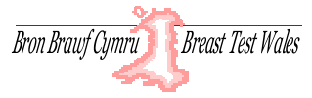 | 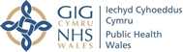

Notes

Aim of Programme

Breast Test Wales is responsible for the NHS breast screening programme in Wales. The aim of the breast screening programme is to reduce morbidity and mortality from breast cancer.

Eligible Population

Women registered with a Welsh GP who are aged 50-70 (or 49 if screening is in their area and they are 50 within the year).

Uptake Target

>=70% of those invited for screening attend.

Lower Layer Super Output Area (LSOA)

Each LSOA meant to have comparable population
Minimum number of residents: 1000
Maximum number of residents: 3000
Number of LSOA’s in Wales (2011 Census): 1909

‘No data reportable’

If number of screening participants <30 the data was deemed not reportable.

Latest Screening Round

Screening was introduced in different areas at different times. The latest screening round per GP practice has been identified (as at 10/11/2015) and the resident postcode of the invited cohort of women used to map LSOA.
Contents

Health Boards
Abertawe Bro Morgannwg University
Aneurin Bevan
Betsi Cadwaladr University
Cardiff & Vale University
Cwm Taf
Hywel Dda
Powys Teaching

Detail Areas
Cardiff
Newport
Swansea
Wrexham
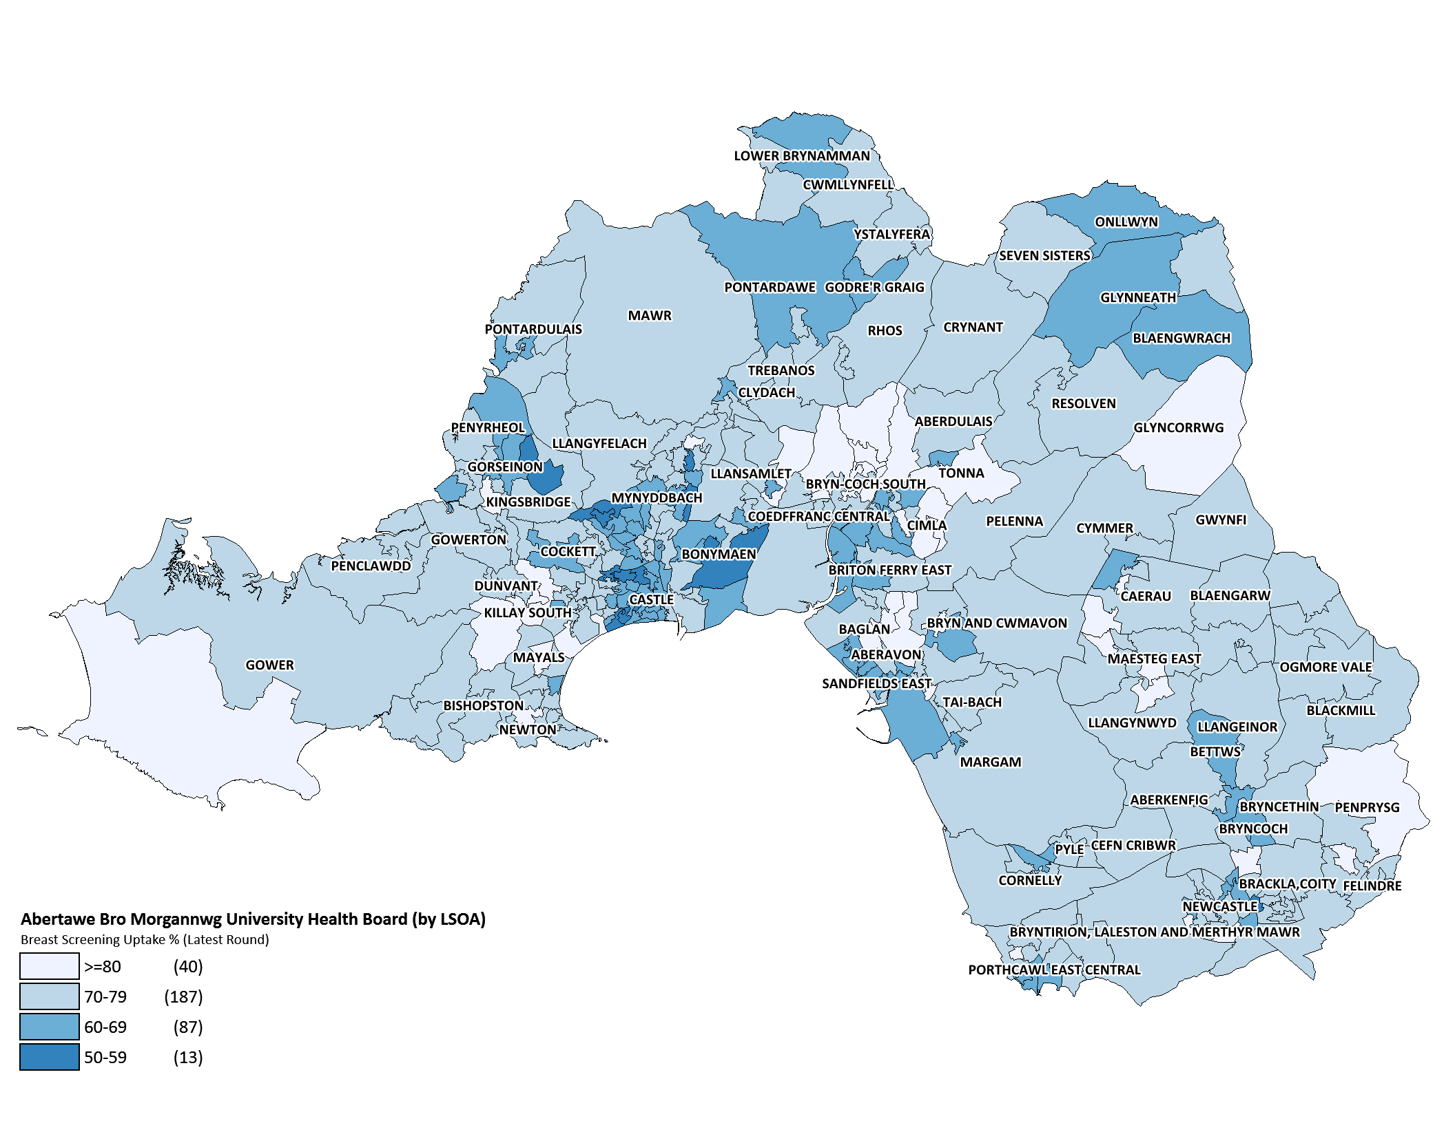
Produced by Public Health Wales, Screening Division. ©Crown Copyright and database right 2015. Ordnance Survey 100044810

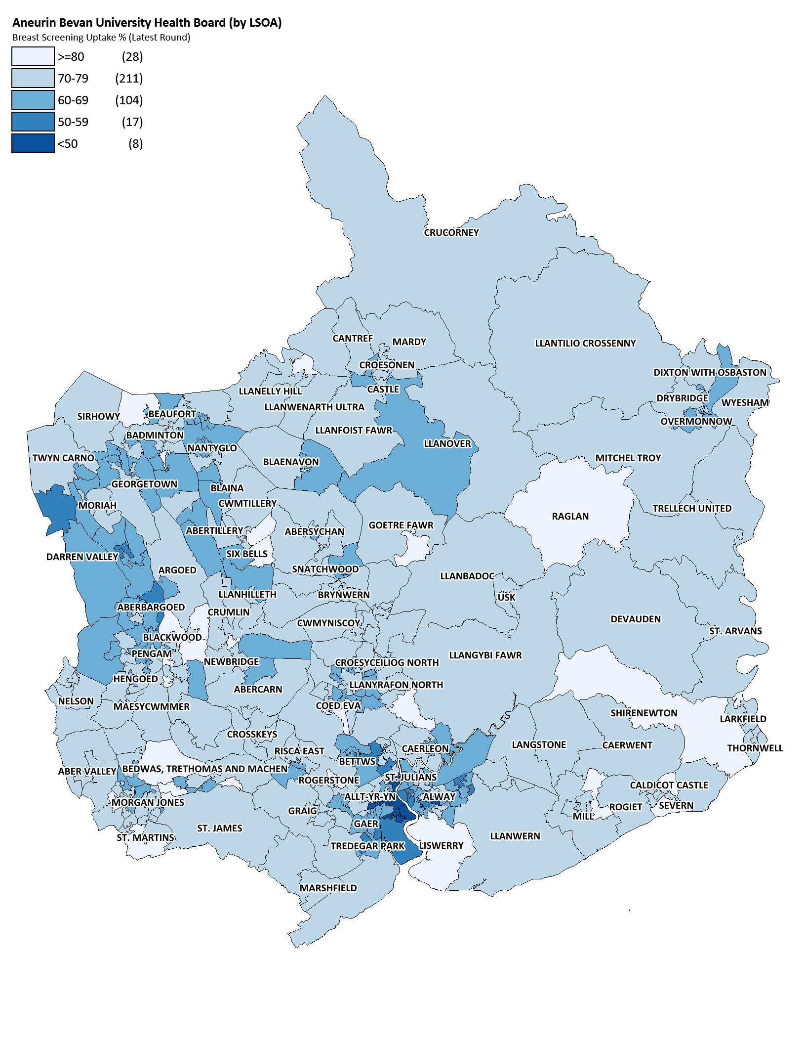
Produced by Public Health Wales, Screening Division. ©Crown Copyright and database right 2015. Ordnance Survey 100044810

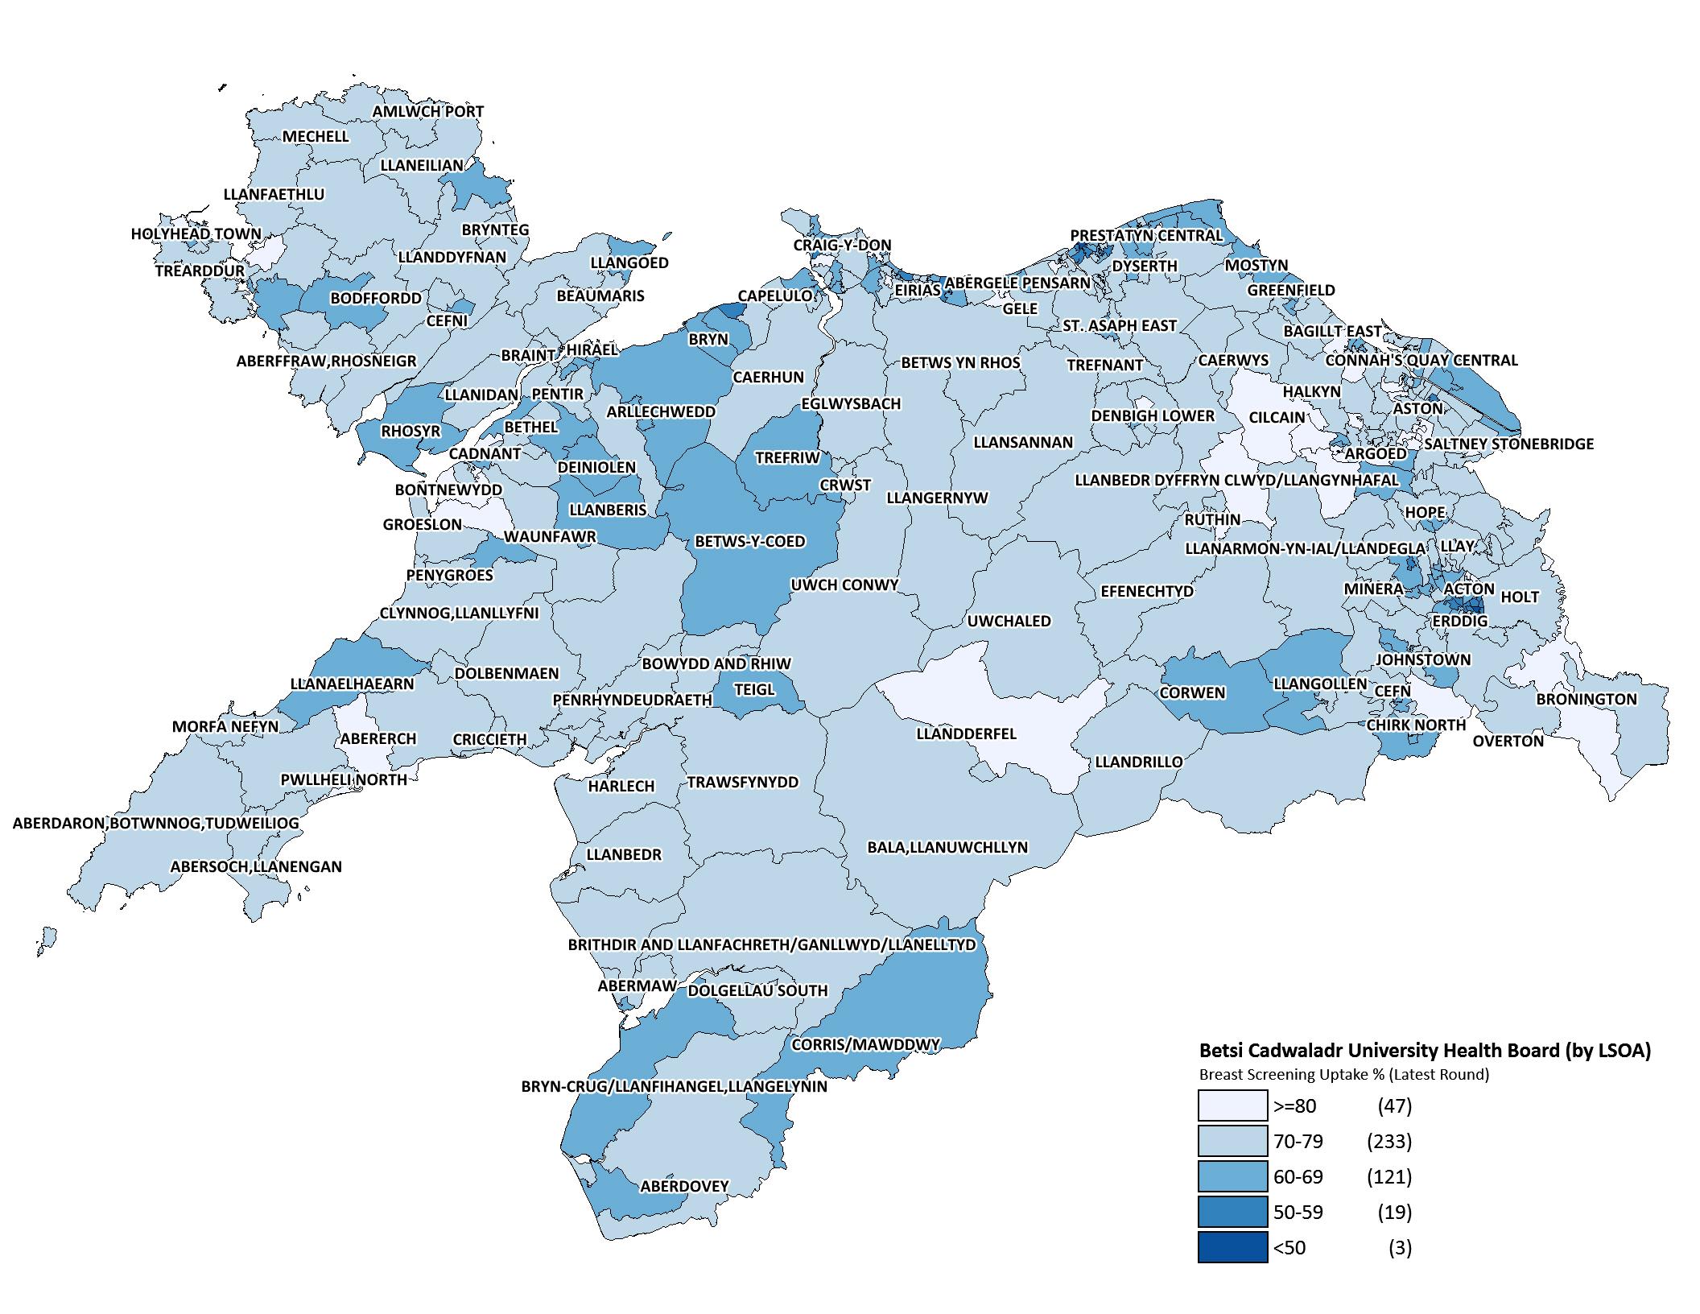
Produced by Public Health Wales, Screening Division. ©Crown Copyright and database right 2015. Ordnance Survey 100044810

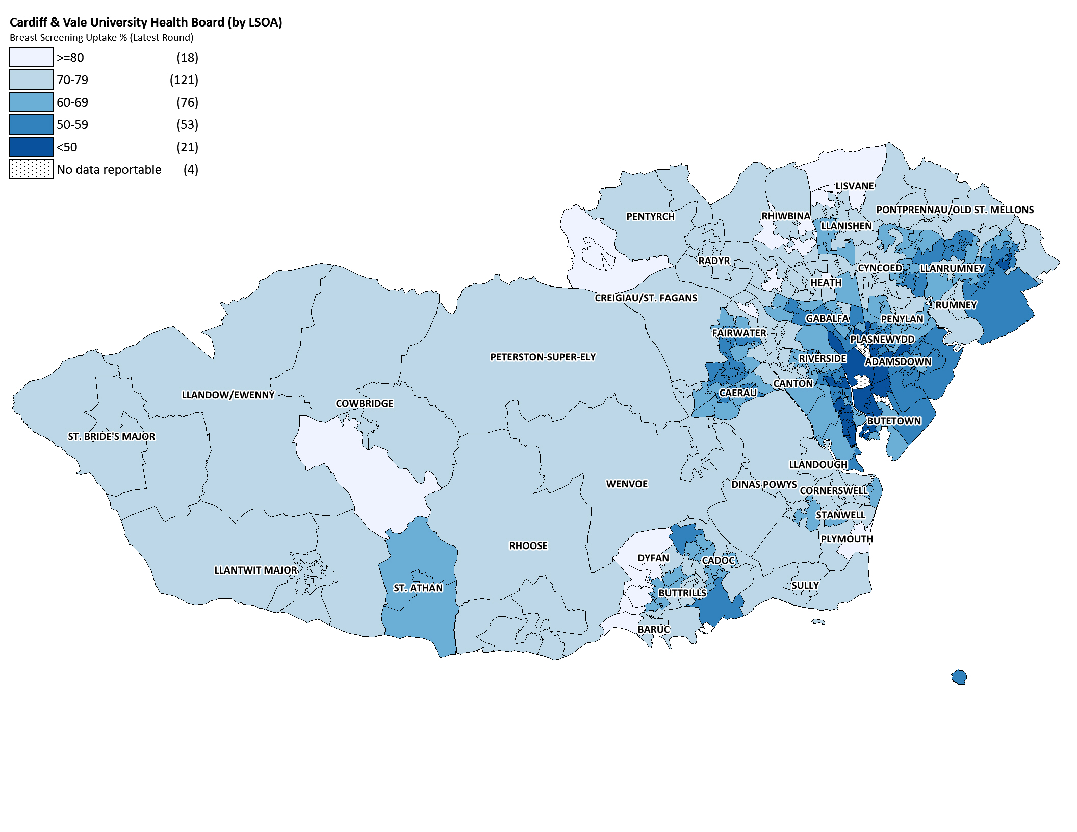
Produced by Public Health Wales, Screening Division. ©Crown Copyright and database right 2015. Ordnance Survey 100044810

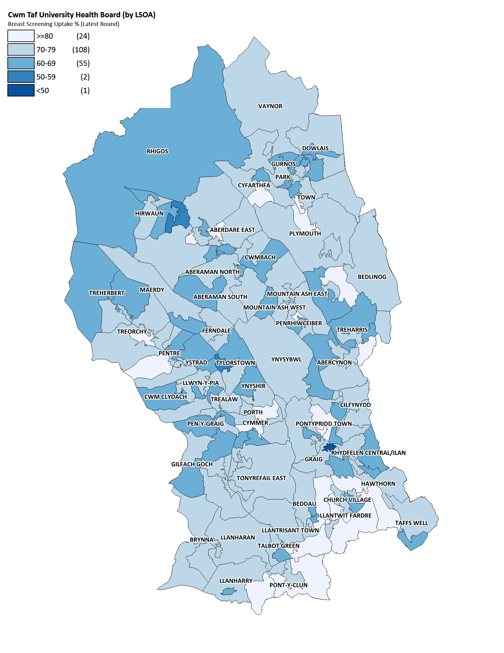
Produced by Public Health Wales, Screening Division. ©Crown Copyright and database right 2015. Ordnance Survey 100044810

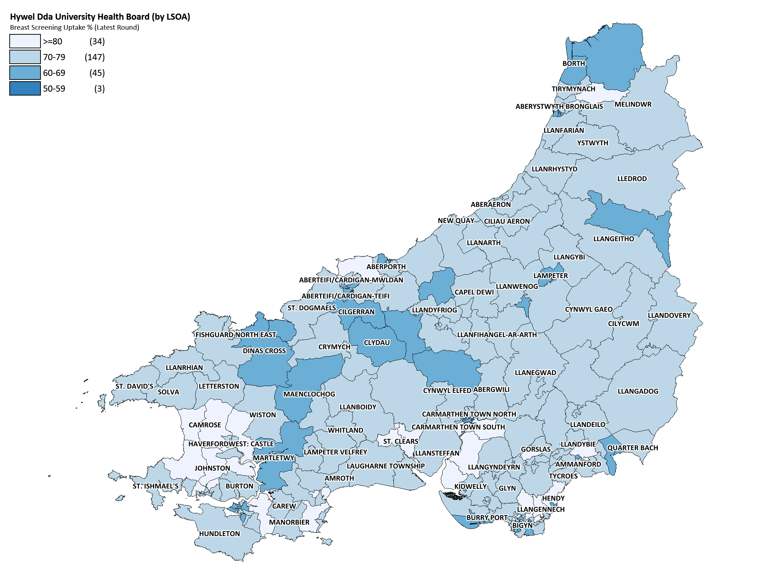
Produced by Public Health Wales, Screening Division. ©Crown Copyright and database right 2015. Ordnance Survey 100044810

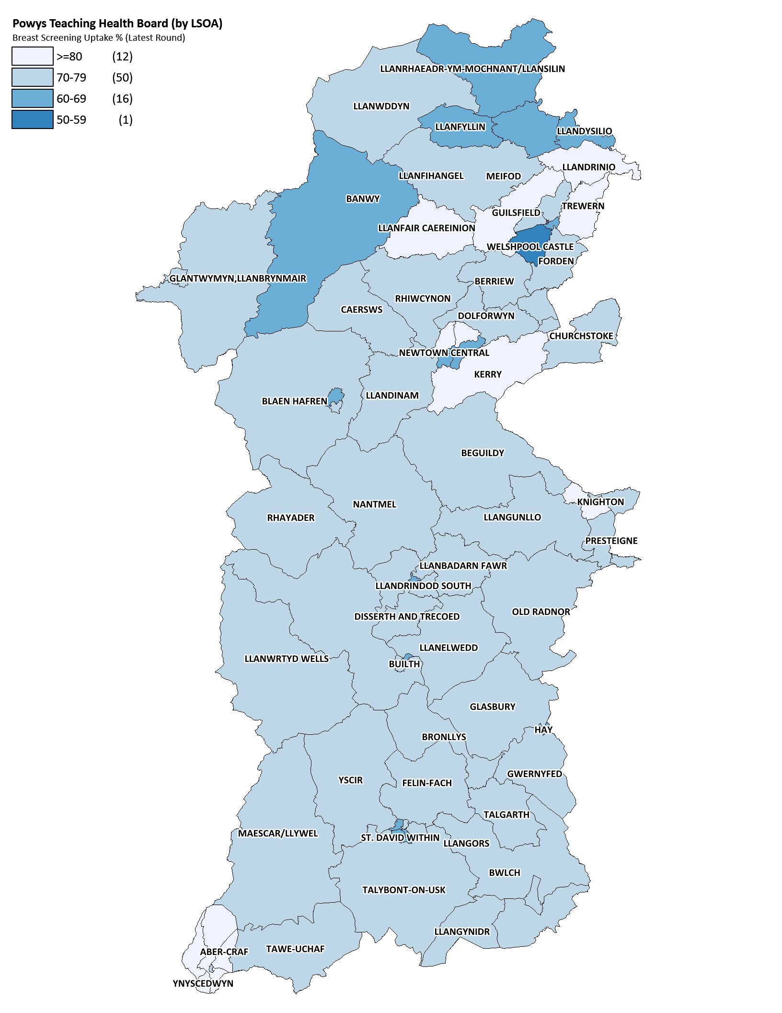
Produced by Public Health Wales, Screening Division. ©Crown Copyright and database right 2015. Ordnance Survey 100044810

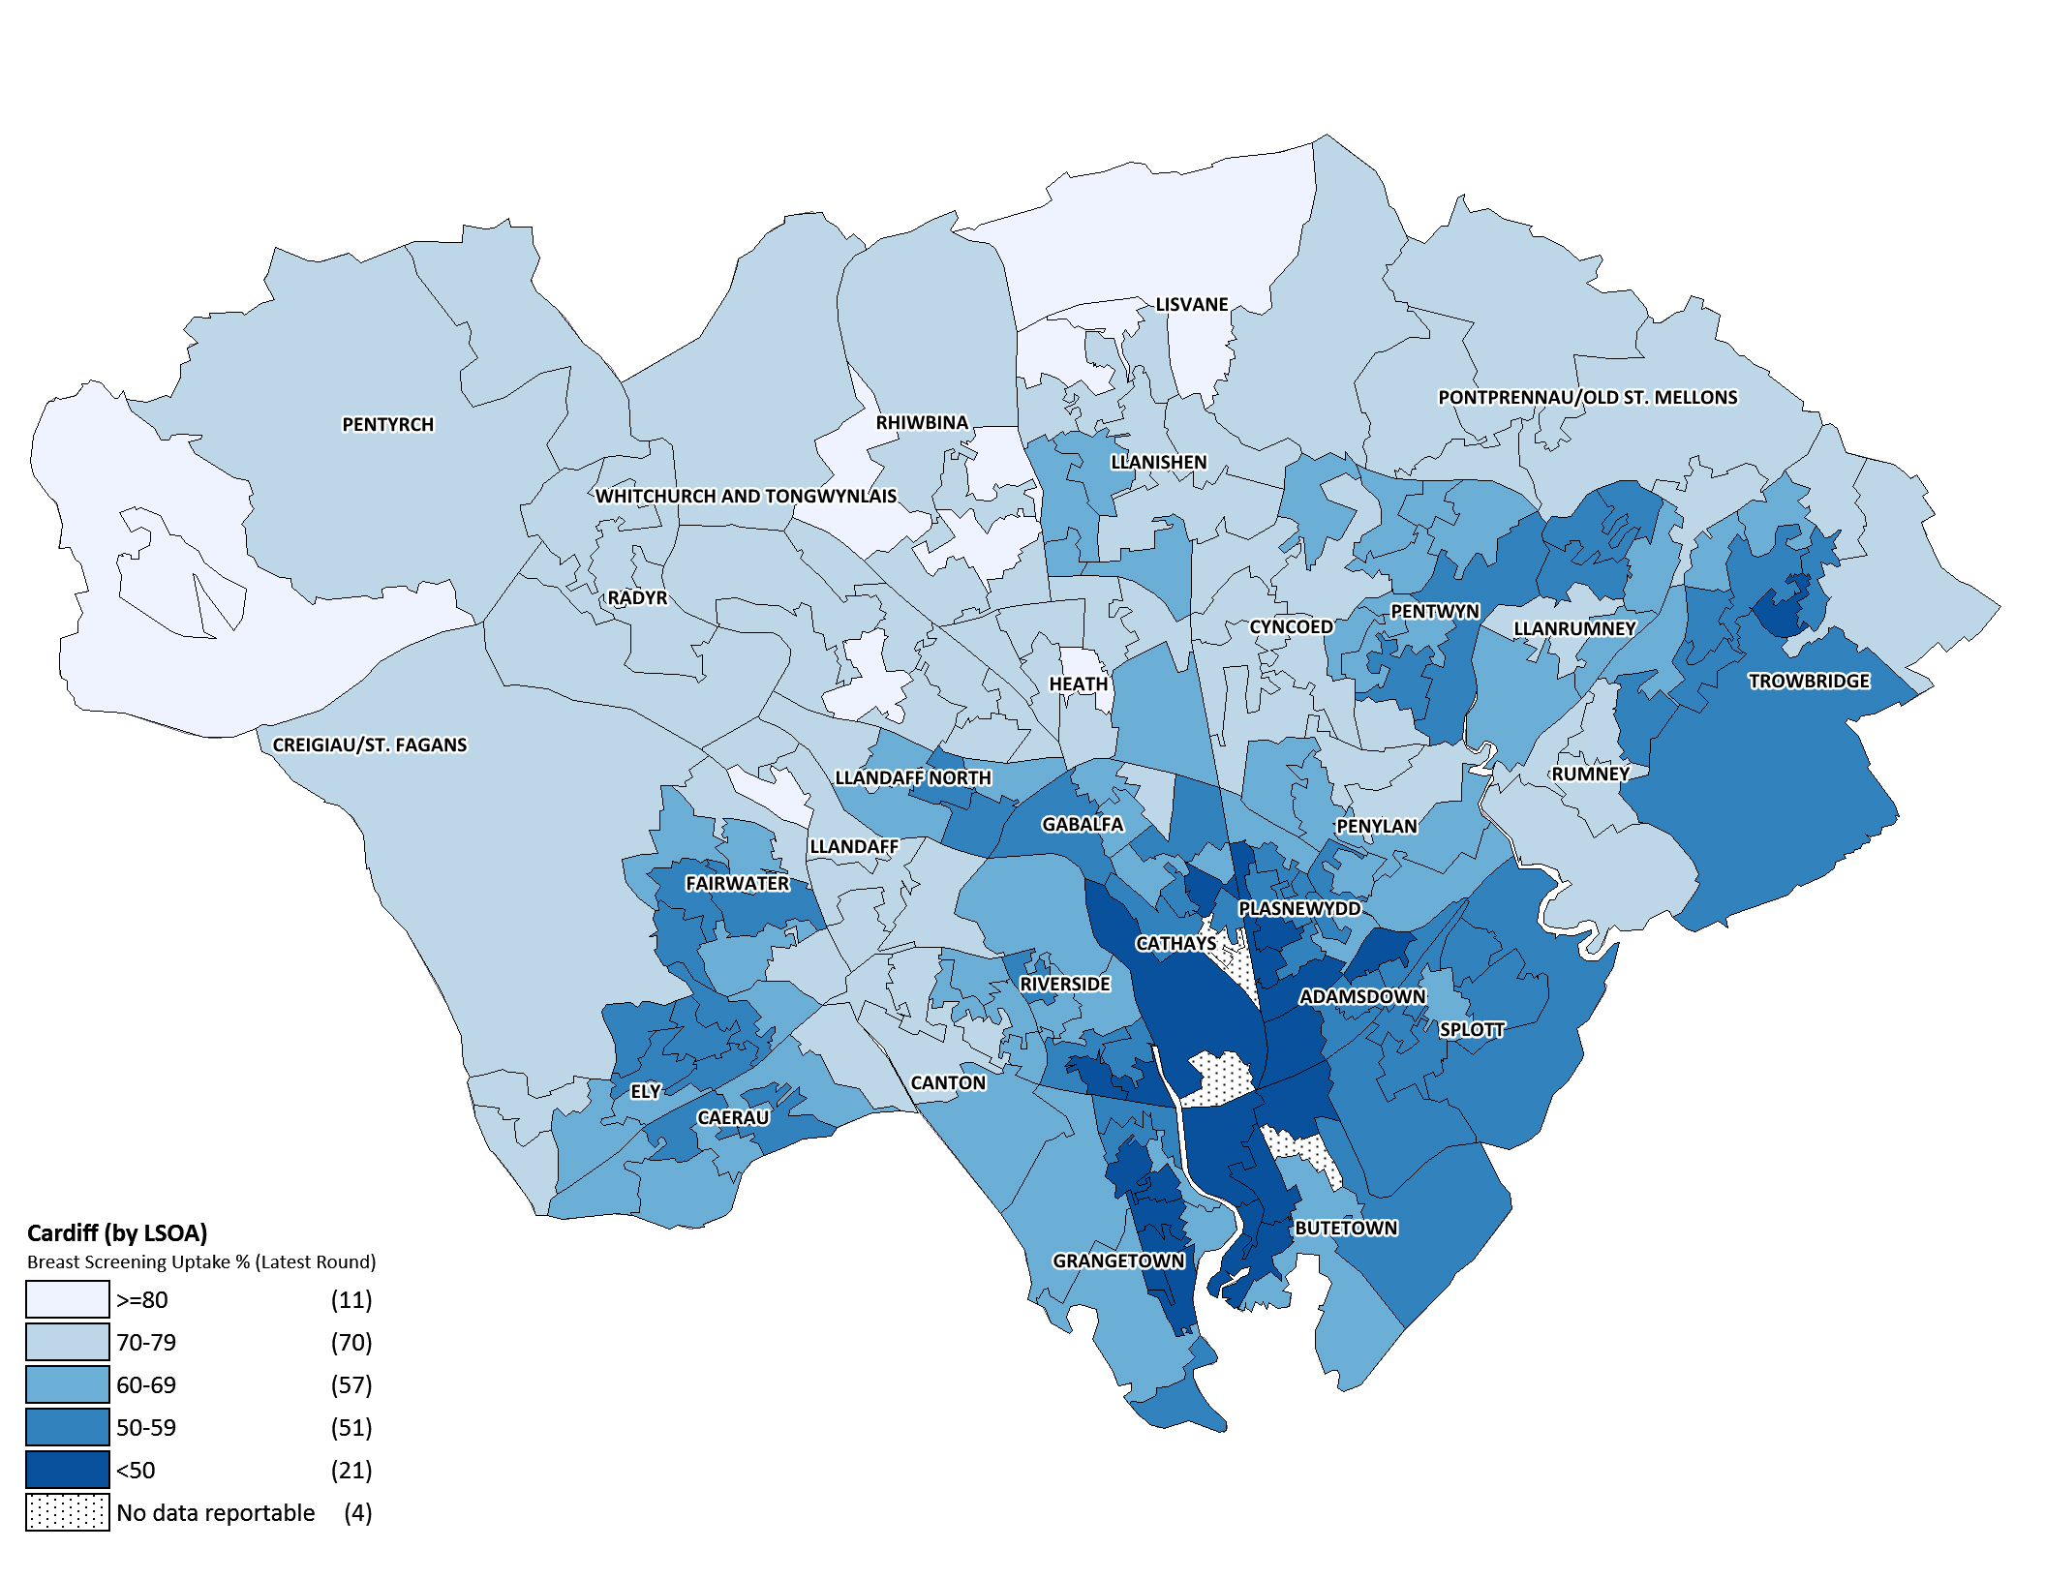
Produced by Public Health Wales, Screening Division. ©Crown Copyright and database right 2015. Ordnance Survey 100044810

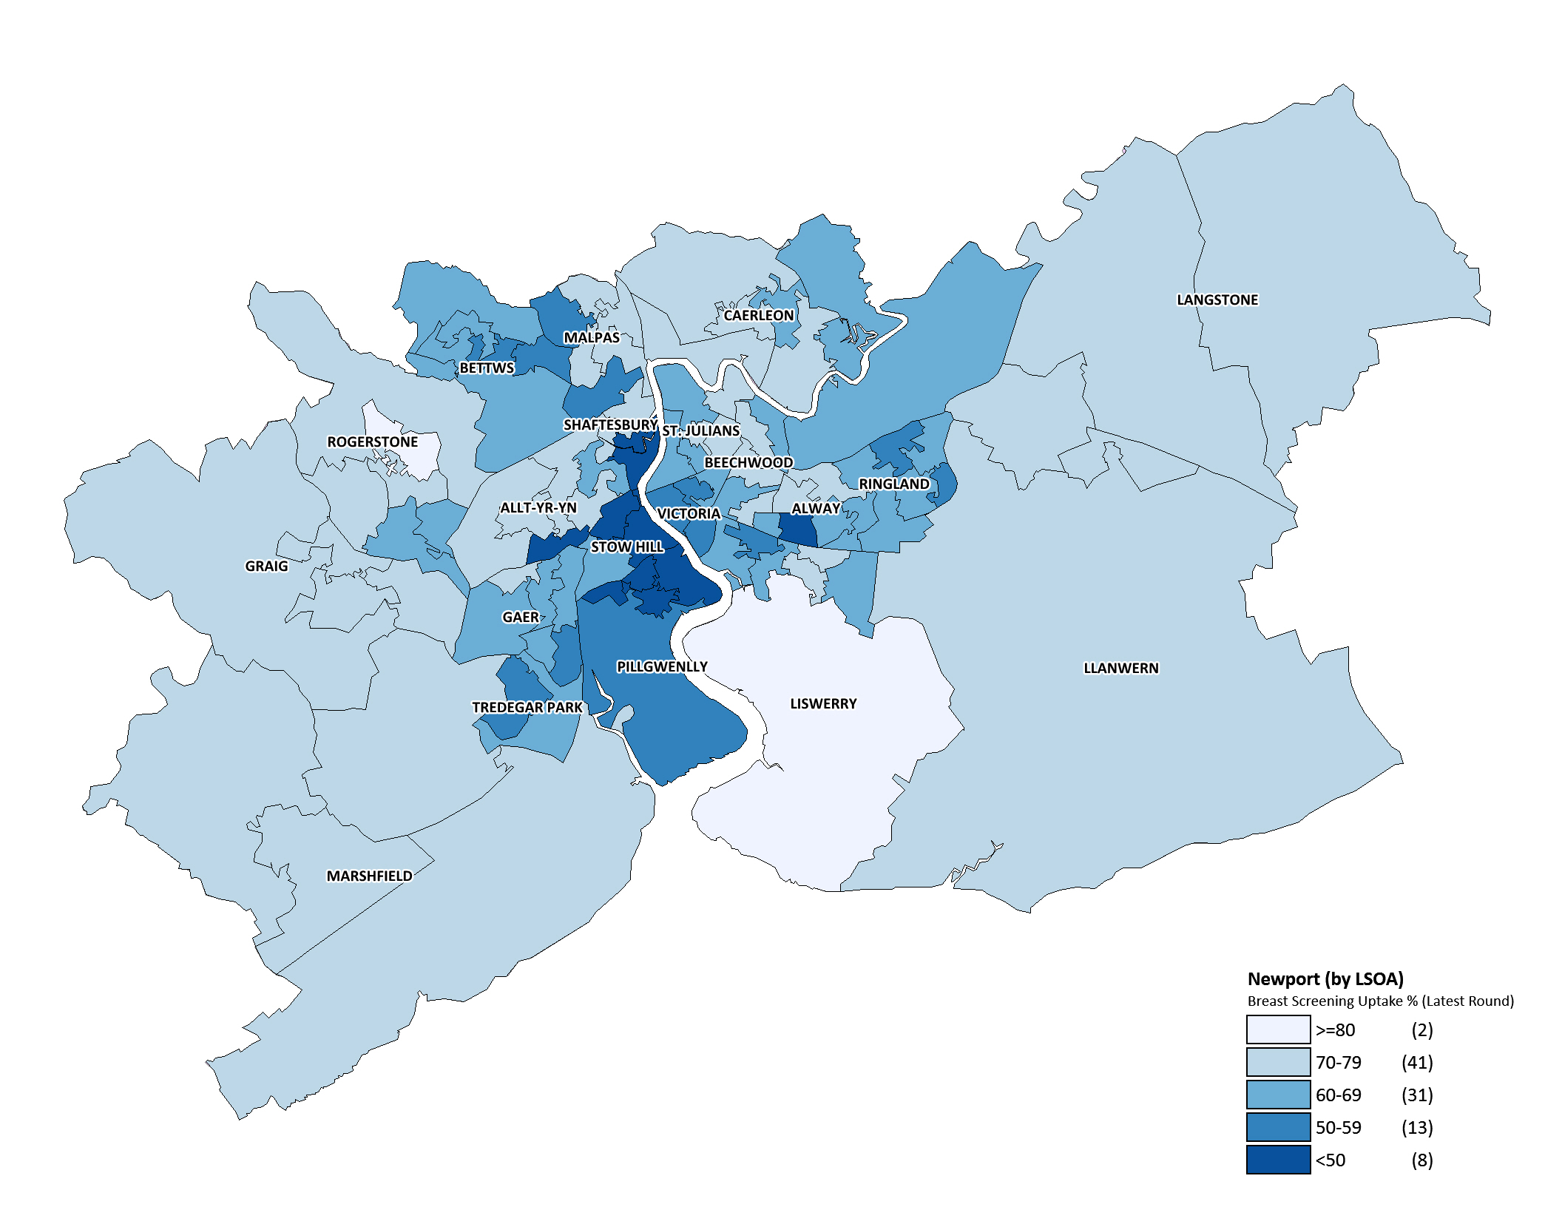
Produced by Public Health Wales, Screening Division. ©Crown Copyright and database right 2015. Ordnance Survey 100044810

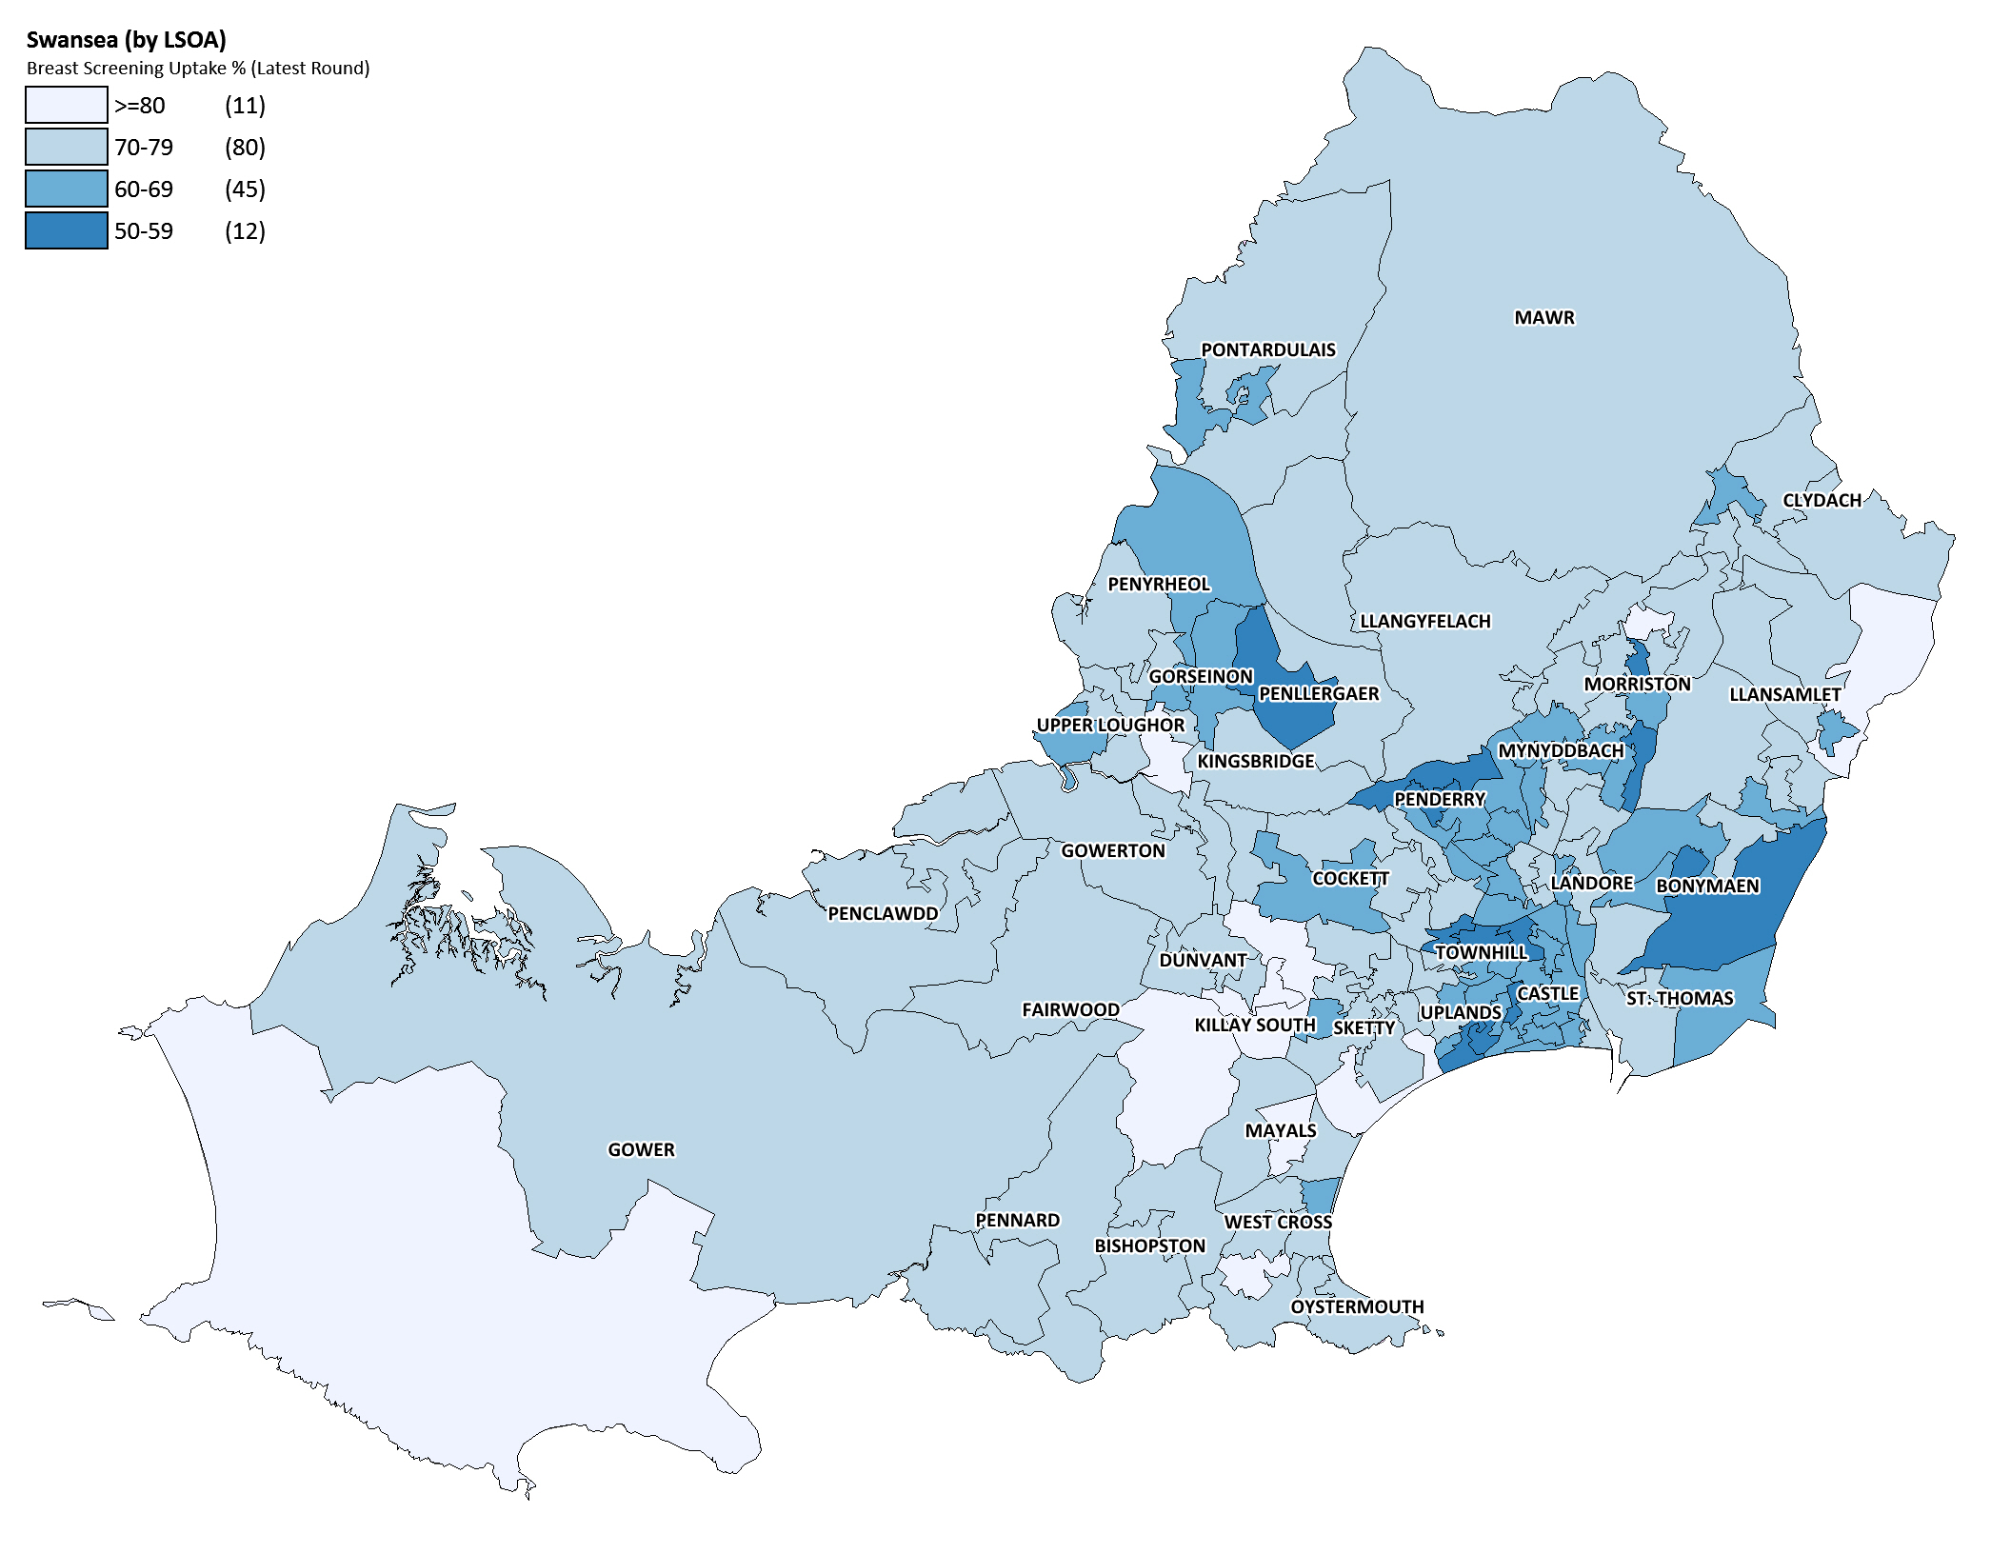
Produced by Public Health Wales, Screening Division. ©Crown Copyright and database right 2015. Ordnance Survey 100044810

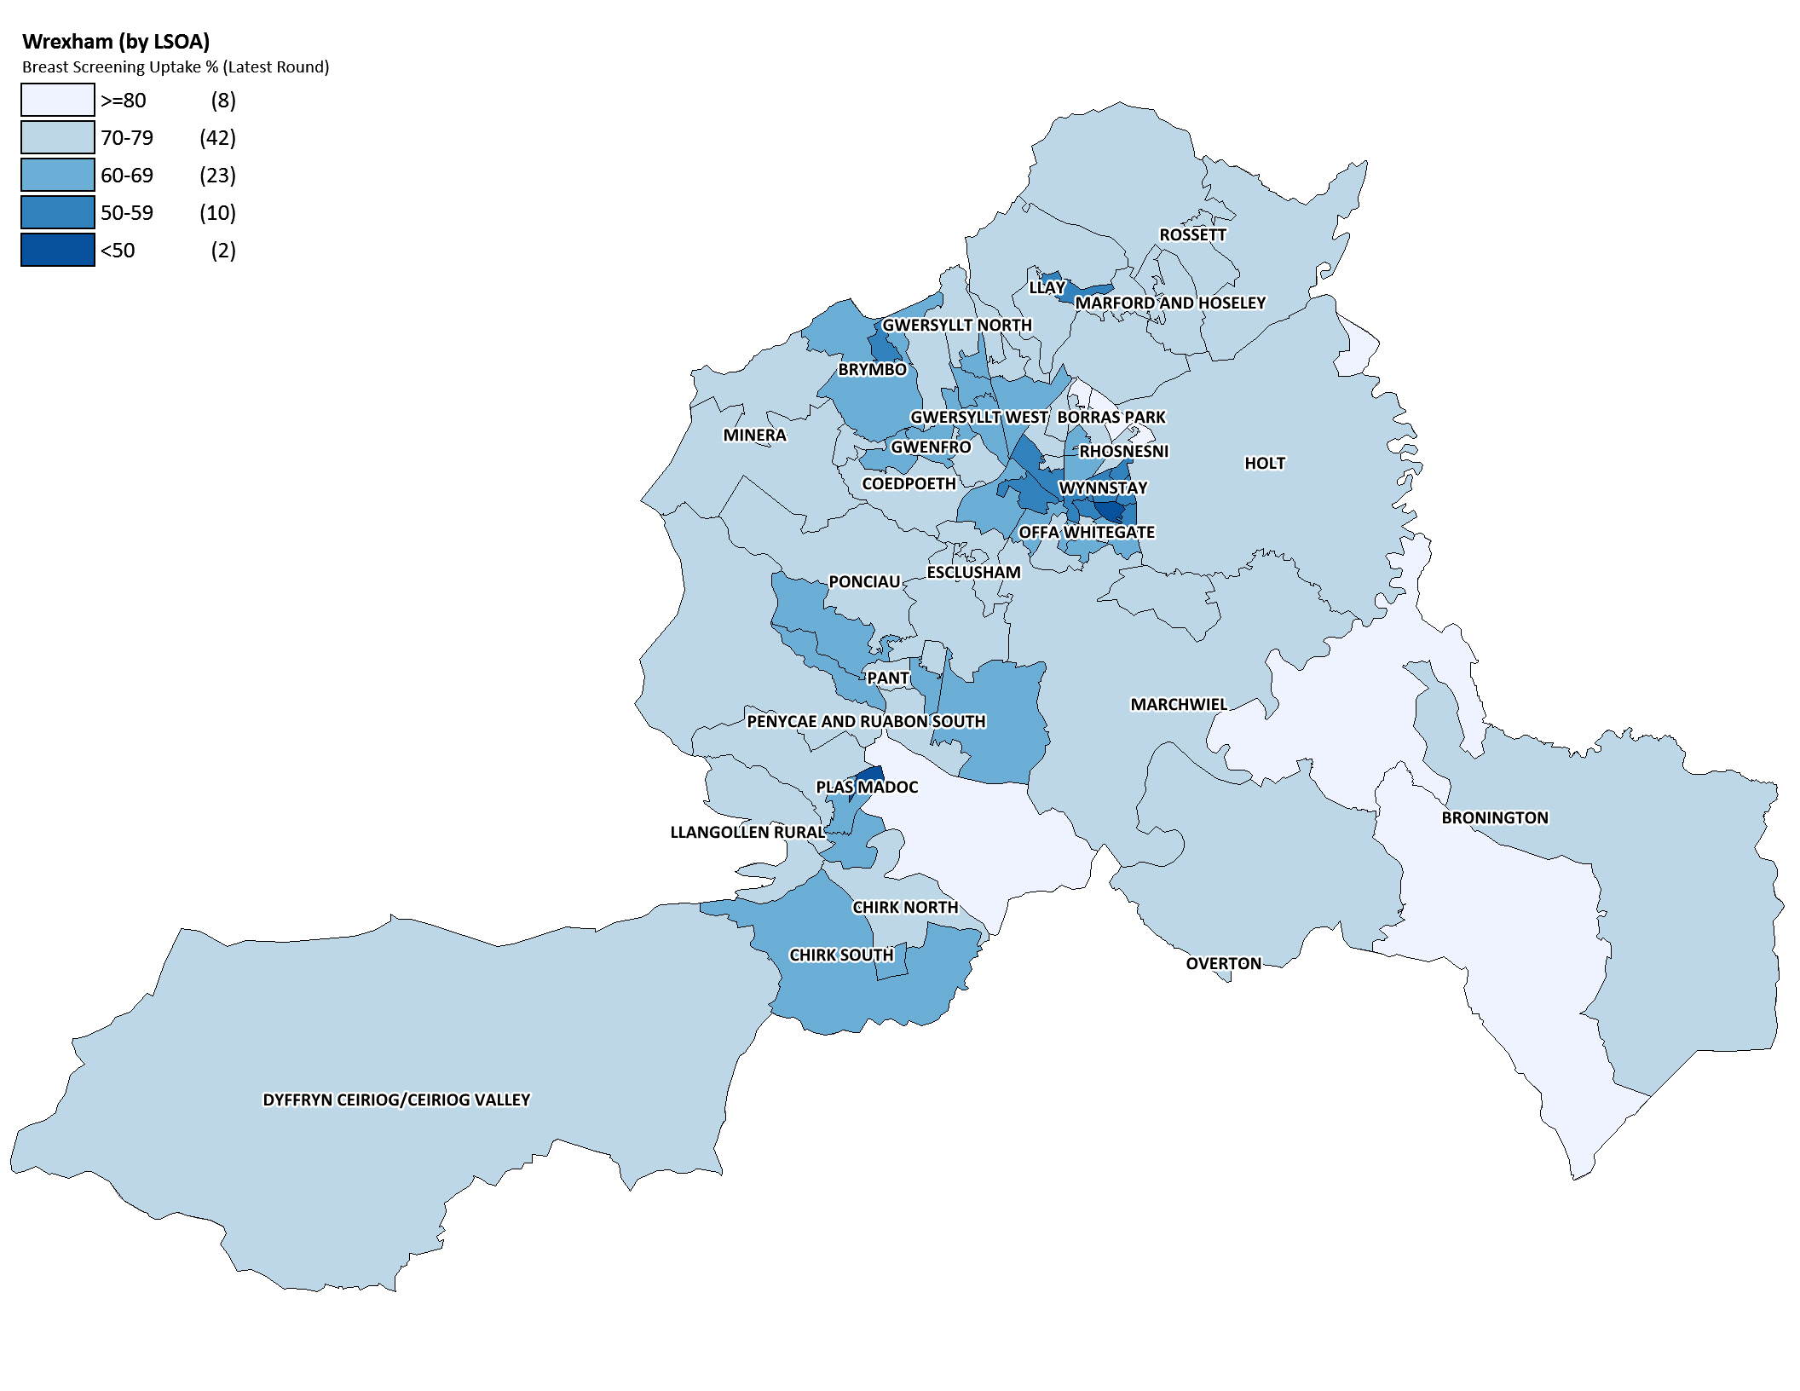
Produced by Public Health Wales, Screening Division. ©Crown Copyright and database right 2015. Ordnance Survey 100044810

Produced by Public Health Wales, Screening Division. ©Crown Copyright and database right 2013. Ordnance Survey 100044810

