[Date] NHS Number:
Address Line 1
Address Line 2
Address Line 3
Address Line 4

Annwyl [Name]

Mae’n amser i chi gael eich brechiad COVID-19
[Add appointment information here]
Os na allwch fynd i’ch apwyntiad neu os oes gennych gwestiynau am eich apwyntiad, gallwch:
- Ffonio ni ar (XXXX) rhwng (insert working hours)
- Anfon e-bost atom (XXXX@wales.nhs.uk)
Rydym yn croesawu e-byst a galwadau ffôn yn Gymraeg. Byddwn yn ymateb yn Gymraeg yn ddi-oed.

Pam mae’r brechlyn yn bwysig?
Gall y brechlyn helpu i leihau eich risg o fynd yn ddifrifol wael o ganlyniad i COVID-19 ac angen gofal ysbyty.

Mae’r brechlyn COVID-19 yn cael ei gynnig i’r bobl ganlynol:
- pobl 75 oed a hŷn;
- preswylwyr mewn cartrefi gofal i bobl hŷn; ac
- unigolion chwe mis oed a throsodd sydd â system imiwnedd wan.

Hyd yn oed os ydych chi wedi cael eich brechu o'r blaen, mae eich amddiffyniad yn pylu ac mae straeniau’r feirws yn newid dros amser. Dyma pam rydych chi'n cael eich gwahodd am ddos arall.

Ydy'r brechlyn yn gweithio?
Mae'r brechlyn yn ddiogel, yn effeithiol a gall helpu i wneud COVID-19 yn salwch ysgafnach os ydych chi'n ei ddal. Mae miliynau o ddosau wedi cael eu rhoi yn ddiogel yn y DU.

Gwnewch bob ymdrech i fynychu'ch apwyntiad i gynnal eich amddiffyniad.
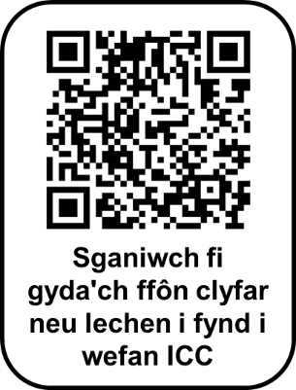
Os hoffech ragor o wybodaeth, gallwch wneud y canlynol:
- mynd i wefan Iechyd Cyhoeddus Cymru (ICC) yn
icc.gig.cymru/brechlyncovid
- sganio’r cod QR
- siaradwch â'r staff gofal iechyd yn eich apwyntiad, neu
- ewch i wefan [Health Board] yn [insert web link]

Yn gywir

Y Tîm Trefnu Apwyntiadau
[Date] NHS Number:
Address Line 1
Address Line 2
Address Line 3
Address Line 4

Dear [Name]

You are now due for your COVID-19 vaccination
[Add appointment information here]
If you cannot attend or have any questions about your appointment, you can:
- Phone us on (XXXX) between (insert working hours)
- Email us at (XXXX@wales.nhs.uk)
Rydym yn croesawu e-byst a galwadau ffôn yn Gymraeg. Byddwn yn ymateb yn Gymraeg yn ddi-oed. We welcome emails and phone calls in Welsh. We will respond in Welsh without delay.

Why is the vaccine important?
The vaccine can help lower your risk of getting seriously ill from COVID-19 and needing hospital care.

The COVID-19 vaccine is being offered to:
- people aged 75 and older;
- residents in care homes for older people; and
- anyone aged six months and over who has a weakened immune system.

Even if you’ve been vaccinated before, your protection fades and virus strains change over time. This is why you’re being invited for another dose.

Does the vaccine work?
The vaccine is safe, effective and can help make COVID-19 a milder illness if you do catch it. Millions of doses have been safely given in the UK.

Please make every effort to attend your appointment to stay protected.

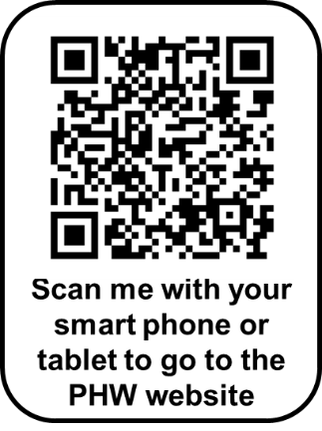
If you would like more information, you can:
- visit the Public Health Wales (PHW) website at
phw.nhs.wales/covidvaccine
- scan the QR code
- speak to the staff at your appointment, or
- visit the [Health Board] website at [insert web link]

Yours sincerely

The Booking Team

