[Enw’r Practis Meddyg Teulu]
[Llinell Cyfeiriad Cyntaf]
[Ail Linell Cyfeiriad]
[Tref/Dinas]
[Cod post]
[Rhif Cyswllt]
[Dyddiad]

Annwyl [Enw]

Mae’ bryd i chi gael eich brechiad rhag yr eryr. Mae'r eryr yn haint sy'n achosi brech boenus ac fe allai arwain at broblemau iechyd hirdymor.

I drefnu apwyntiad, gallwch wneud y canlynol: [dileer a chwblhau gyda manylion
- ffonio ni ar (XXXX);
- cysylltu â ni drwy ein gwefan yn (XXXX); neu
- anfon e-bost aton ni yn (XXXX).]

Mae'r eryr yn fwy cyffredin ymhlith oedolion hŷn. Mae'r brechiad yn lleihau eich risg o gael yr eryr. Bydd angen dau ddos ​​o'r brechlyn arnoch. Os byddwch yn cael yr eryr, mae'n debygol o fod yn salwch mwynach a byrrach.

Hyd yn oed os ydych eisoes wedi cael yr eryr, dylech gael y brechlyn o hyd gan y bydd yn lleihau eich risg o gael yr eryr eto.
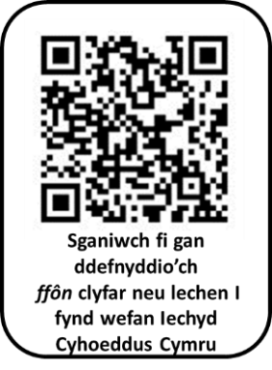
Os hoffech ragor o wybodaeth, gallwch wneud y canlynol:
- mynd i wefan Iechyd Cyhoeddus Cymru yn icc.gig.cymru/yr-eryr;
- sganio'r cod QR; neu
- gysylltu â'ch practis meddyg teulu.

Os ydych chi’n credu eich bod eisoes wedi cael brechlyn rhag yr eryr, rhowch wybod i ni.

Yr eiddoch yn gywir

Dr [Enw] a phartneriaid
Practis Meddyg Teulu [Enw]
-----------------------------------------------------------------------------------------------------------------
Defnyddiwch y gofod isod i ysgrifennu dyddiad ac amser eich apwyntiad.

Rwy'n mynd i gael fy mrechiad rhag yr eryr ar:

Dyddiad:

Amser:

[Insert GP Surgery]
[First Address Line]
[Second Address Line]
[Town/City]
[Postcode]
[Contact Number]
[Date]

Dear [Name]

You are due for your shingles vaccination. Shingles is an infection that causes a painful rash and may lead to long-lasting health problems.

To book your appointment, you can: [delete and complete with details
- phone us on (XXXX);
- contact us through our website at (XXXX); or
- email us at (XXXX).]

Shingles is more common in older adults. The vaccination reduces your risk of getting shingles. You will need two doses of the vaccine. If you do get shingles, it is likely to be a milder and shorter illness.


Even if you’ve already had shingles, you should still get the vaccine as it will lower your risk of getting shingles again.

If you would like more information, you can:
- visit the Public Health Wales website at phw.nhs.wales/shingles;
- scan the QR code; or
- contact the surgery.

If you think you have already had a shingles vaccine, please let us know.

Yours sincerely

Dr [Name] and partners
[Name] Surgery
-----------------------------------------------------------------------------------------------------------------
Please use the space below to write down the date and time of your appointment.

I am going for my shingles vaccination on:

Date:

Time:

