[Insert GP Surgery]
[First Address Line]
[Second Address Line]
[Town/City]
[Postcode]
[Date]

Annwyl [Name]

Fe’ch gwahoddir i gael eich brechlyn rhag yr eryr am ddim. Mae’r brechlyn yn cael ei argymell i bob oedolyn sydd â system imiwnedd wan iawn.

Mae’r eryr yn haint sy’n gallu achosi brech boenus a phoen nerf hirdymor (a elwir yn niwralgia ôl-herpetig neu PHN). Gall PHN fod yn anodd ei drin a gall bara am fisoedd neu fwy.

Mae'r brechlyn rhag yr eryr yn ddiogel a bydd yn helpu i’ch amddiffyn rhag yr eryr a PHN. Bydd angen dau ddos​​​​ arnoch chi, o leiaf ddau fis ar wahân.

I drefnu eich apwyntiad brechu, gallwch: [delete and complete with details]
- ein ffonio ni ar (XXXX);
- gysylltu â ni drwy ein gwefan yn (XXXX); neu
- anfon e-bost aton ni yn (XXXX).]

Efallai y byddwch chi'n dal i gael yr eryr ar ôl i chi gael y brechlyn, ond mae'n debygol y bydd yn salwch ysgafnach.

Os ydych chi eisoes wedi cael yr eryr, gallwch chi gael y brechlyn o hyd gan y bydd yn helpu i leihau eich risg o gael yr eryr eto.

I gael rhagor o wybodaeth gallwch:
- fynd i wefan Iechyd Cyhoeddus Cymru yn icc.gig.cymru/yr-eryr
- sganio'r cod QR; neu
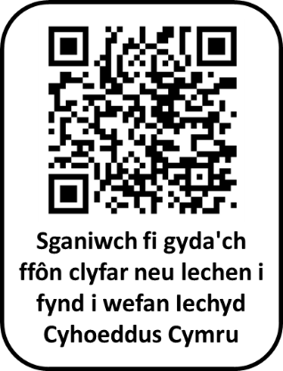
- gysylltu â'ch practis meddyg teulu.

Edrychwn ymlaen at eich gweld yn eich apwyntiad brechu.

Yn gywir,

Dr [Name] a phartneriaid
Practis Meddyg Teulu [Name]

-----------------------------------------------------------------------------------------------------------------
Defnyddiwch y lle gwag isod i ysgrifennu dyddiad ac amser eich apwyntiad.

Rwy'n mynd i gael fy mrechiad rhag yr eryr ar:

Dyddiad: Amser:

[Insert GP Surgery]
[First Address Line]
[Second Address Line]
[Town/City]
[Postcode]
[Date]

Dear [Name]

You are invited to have your free shingles vaccine. This is recommended to all adults who have a very weak immune system.

Shingles is an infection that can cause a painful rash and long-lasting nerve pain (called post-herpetic neuralgia or PHN). PHN can be difficult to treat and can last for months or longer.

The shingles vaccine is safe and will help protect you from getting shingles and PHN. You’ll need two doses, given at least two months apart.

To book your vaccination appointment, you can: [delete and complete with details
- phone us on (XXXX)
- contact us through our website at (XXXX), or
- email us at (XXXX).]

You may still get shingles after having the vaccine, but it’s likely to be milder.

If you’ve already had shingles, you can still have the vaccine as it will help reduce your risk of having shingles again.

For more information you can:
- visit the Public Health Wales website at phw.nhs.wales/shingles
- scan the QR code, or

- contact the surgery.

We look forward to seeing you for your vaccination.

Yours sincerely,

Dr [Name] and partners
[Name] Surgery

-----------------------------------------------------------------------------------------------------------------
Please use the space below to write down the date and time of your appointment.

I am going for my shingles vaccination on:

Date: Time:

