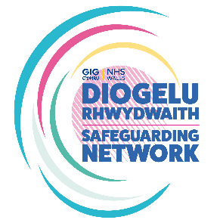
The All-Wales Female Genital Mutilation Paediatric Pathway Audit Tool

Name of Professional conducting Audit:
Role/Designation:
Division/Department:
Timeframe of Audit
Start Date: |  | End Date:
Record Type (eg paper/electronic):
Record Reference Number/Code:

FGM Paediatric Pathway <18 years old
- a. Was FGM self-reported?  b. Was FGM identified by a health professional? | Yes / No  Yes / No
- Which staff group identified FGM?

- Was mandatory reporting undertaken as referenced in section 7 of the Pathway? | Yes / No
- Was an at Risk Safeguarding Report submitted to the Police and Social Services under the duty to report process of the Wales Safeguarding Procedures (2019)? | Yes / No
- Was safeguarding considered for other female children/siblings? | Yes / No / Not applicable
- Was a referral made to an experienced professional e.g. SARC Paediatrician for examination? | Yes / No
- a. Is it recorded that consent for the examination was obtained?  b. Was an interpreter required/used? | Yes / No  Yes / No / Not required
- a. Was a referral for psychological support made?  b. If not, were reasons provided? | Yes / No  Yes / No
- a. Was this reported as a National Reportable Incident (NRI)?  b. Was this reported on Datix? | Yes / No  Yes / No
- Were all relevant documents (at risk safeguarding reports) included within the records/on Datix? | Yes / No
- Is there evidence of a clear plan of care? | Yes / No
- a. Was the information about FGM shared?  b. If so, with whom (eg GP, Health Visitor, School Nursing/other)? | Yes / No
- Has the FGM Pathway been fully completed? | Yes / No / Partially
Auditors’ comments:

