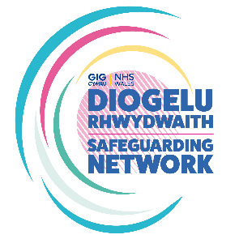
The All-Wales Female Genital Mutilation Adult Pathway Audit Tool

Name of Professional conducting Audit:
Role/Designation:
Division/Department:
Timeframe of Audit
Start Date: |  | End Date:
Record Type (eg paper/electronic):
Record Reference Number/Code:

FGM Adult Pathway >18 years old
- a. Was FGM self reported?  b. Was FGM identified by a health professional? | Yes / No  Yes / no
- Which staff group identified FGM?

- Has the checklist within the FGM Pathway (Appendix 1) been completed? | Yes / Partially / No
- Is there a clear plan for examination to identify the type of FGM? | Yes / No
- Is it recorded that consent for the examination was obtained?  Was an interpreter required/used? | Yes / No  Yes / No / Not Required
- Were support options discussed? (eg BAWSO) | Yes / No / Unknown / Declined
- Was FGM legislation discussed and documented? | Yes / No
- Was the DOH (2017) risk assessment completed for any female children from wider family members? FGM Professional Guidance Forms (publishing.service.gov.uk) | Yes / No
- Were At Risk Safeguarding Reports submitted?  If so, for whom? | Yes / No  Adult  Child  Unborn
- Was the adult informed that FGM information will be shared with GP and other relevant professionals? | Yes / No
- Is there evidence of a clear plan of care? | Yes / No
- Has the FGM Pathway been fully completed? | Yes / No / Partially
Auditors’ comments:

