



 |  |  | Name of Meeting  Board
Date of Meeting
26 March 2025
Agenda item:
4.5
Update to the Public Health Wales Standing Orders and Reservations and Delegations of Powers
Executive lead: |  |  |  | Paul Veysey – Board Secretary and Head of the Board Business Unit
Author: |  |  |  | Paul Veysey – Board Secretary and Head of the Board Business Unit
Approval/Scrutiny route: |  |  |  | - BET - 5 March 2025  - ACGC - 10 March 2025  - Board for Adoption on 25 March 2025
Purpose
To present to ACGC the revised Standing Orders and Reservations and Delegations of Powers issued by Welsh Government and to identify the changes proposed.
Recommendation:
APPROVE | CONSIDER |  |  |  | RECOMMEND | ADOPT | ASSURANCE
The Board is asked to:

- Consider the proposed revisions to Standing Orders and Reservations and Delegations of Powers
- Note that the Audit and Corporate Governance Committee considered the proposed changes at its meeting on 10 March 2025, and recommended the revised version to the Board for approval.
- Approve the proposed changes.

Link to Public Health Wales Strategic Plan

Public Health Wales has an agreed strategic plan, which has identified seven strategic priorities and well-being objectives.

This report contributes to the following:
Strategic Priority/Well-being Objective |  | All Strategic Priorities/Well-being Objectives
Strategic Priority/Well-being Objective |  | Choose an item.
Strategic Priority/Well-being Objective |  | Choose an item.
Summary impact analysis

Equality and Health Impact Assessment |  | An Equality and Health Impact Assessment has been completed and accompanies the papers.
Risk and Assurance |  | The Standing Orders and Scheme of Reservation and Delegation of Powers provides assurance that appropriate arrangements are in place within the organisation to make decisions.
Health and Care Standards |  | This report supports and/or takes into account the Health and Care Standards for NHS Wales Quality Themes
 |  | Governance, Leadership and Accountability
 |  | Choose an item.
 |  | Choose an item.
Financial implications |  | N/A
People implications |  | N/A

Purpose / situation

Following changes to the Membership Regulations of Health Bodies in Wales, the Cabinet Secretary has written to all Chairs requesting amendments are made to our Standing Orders.

The purpose of this paper is to set out the changes required to the current Standing Orders in order for BET to recommend the proposed changes to the Board for adoption on 25th March 2025. Our Audit and Corporate Governance Committee will also consider the proposed changes on 10th March 2025.

The changes relate to the timings around notice of and papers / agendas for Board and Committee meetings.

Background

The Standing Orders and Reservation and Delegation of Powers (SOs), together with a range of other framework documents, are designed to translate the statutory requirements set out in Public Health Wales National Health Service Trust (Membership and Procedure) Regulations 2009 (2009/1385) (as amended) into day-to-day operating practice. Together with the adoption of a Schedule of Decisions Reserved to the Board; a Scheme of Decisions to Officers and others; and Standing Financial Instructions (SFIs), they provide the regulatory framework for the business conducted by the Trust.

The Local Health Boards, NHS Trusts and Special Health Authorities (Constitution, Membership and Procedures) (Miscellaneous Amendments) (Wales) Regulations 2024 came into force on the 20 January 2025. These Regulations amended the Local Health Boards (Constitution, Membership and Procedures) (Wales) Regulations 2009, The Public Health Wales National Health Service Trust (Membership and Procedure) Regulations 2009, The National Health Service Trusts (Membership and Procedure) Regulations 1990 and The Health Education and Improvement Wales Regulations 2017.

The purpose of these amendments is to ensure greater consistency across the health bodies in Wales.

In the context of Public Health Wales, the changes made relate solely to the timescales for the publication of board and committee agendas and papers.

The amendments set out supersede those issued on 23 April 2024 (which formed the basis of the revied Standing Orders approved by the Board in May 2024) and as confirmed in Welsh Health Circular WHC/2024/019. A new WHC will be issued to confirm the amendments required. For the time being, the requirement to amend arises from a Welsh Minister Direction.

Changes

Clause 7.4.3 changes from:

Board members shall be sent an Agenda and a complete set of supporting papers at least 7 calendar days before a formal Board meeting.

To:

Board members shall be sent an Agenda and a complete set of supporting papers at least 5 clear days before a formal Board meeting.

In this context, 5 clear days are calendar days and do not include the date the papers were sent or the date of the meeting. For example, if a meeting was due to take place on Wednesday the 29th of January, the papers should be sent on Thursday the 23rd of January – leaving 5 clear days between the date the papers were sent and the date the meeting taking place – despite there being a weekend in between.

Clause 7.4.7 changes in red:

Except for meetings called in accordance with Standing Order 6.3, at least 10 7 calendar days before each meeting of the Board a public notice of the time and place of the meeting, and the public part of the agenda, shall be displayed bilingually (in English and Welsh):

- On the Trust’s website, together with the papers supporting the public part of the Agenda; as well as
- Through other methods of communication as set out in the Trust’s communication strategy.

7.4.8 When providing notification of the forthcoming meeting, the Trust shall set out when and how the Agenda and the papers supporting the public part of the Agenda may be accessed, in what language and in what format, e.g., as Braille, large print, easy read, etc. The agenda and papers will be made available to the public at least 5 clear days before each meeting of the Board.

  - Summary

The changes proposed are sensible, manageable and will be owned by the Board Business Unit.

Well-being of Future Generations (Wales) Act 2015

This work has been put together following the five ways of working, as defined within the sustainable development principle in the Act, in the following ways:

 | The Standing Orders and Reservation and Delegation of Powers provide the organisation with a long-term framework within which it operates
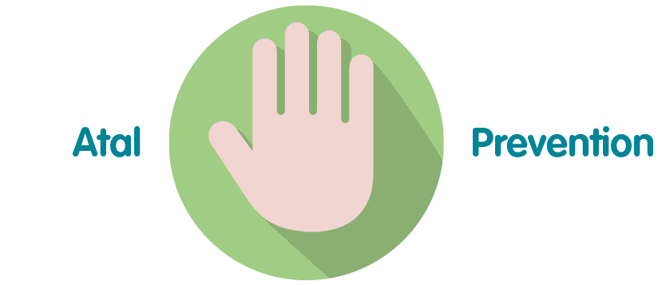 | The Standing Orders and Reservation and Delegation of Powers provide staff with guidance to prevent non-compliance
 | The Standing Orders and Reservation and Delegation of Powers ensure decision making is integrated across the organisation
 | The Standing Orders and Reservation and Delegation of Powers are based on the model standing orders issued by Welsh Government, which were reviewed and developed on a collaborative basis.
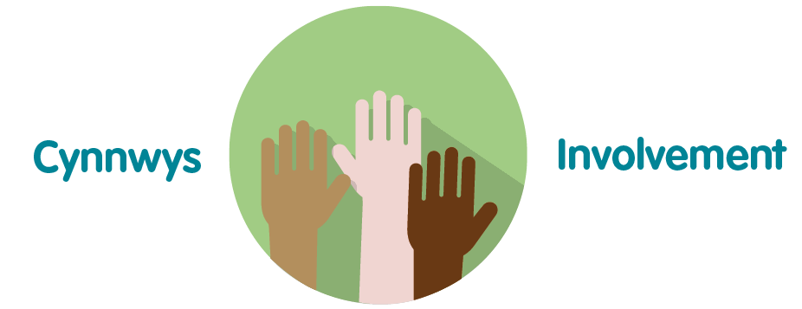 | The Standing Orders and Reservation and Delegation of Powers are based on the model standing orders issued by Welsh Government, which were reviewed and developed in conjunction and consultation with relevant stakeholders.

- Recommendation

The Board is asked to:

- Consider the proposed revisions to Standing Orders and Reservations and Delegations of Powers
- Note that the Audit and Corporate Governance Committee considered the proposed changes at its meeting on 10 March 2025, and recommended the revised version to the Board for approval.
- Approve the proposed changes.

