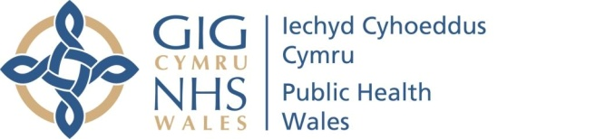 |  | Name of Meeting  Board
Date of Meeting
26 January 2023
Agenda item
9.1
Chair’s Report to the Board concerning the matters considered in the Private Board meeting of the 24 November 2022.

Chair | Jan Williams
Date of last meeting | 24 November 2022

Summary of the key matters that the Board considered when meeting in private session, on 24 November 2022, together with any related decisions made:
In line with Public Health Wales’ Standing Orders, the Board conducts its meetings in public. Public Health Wales’ Standing Orders make provision, at paragraph 7.5.2, for the Board to meet and discuss certain matters in private.

The Public Bodies Act (Admission to Meetings) Act 1960, section 1 (2) provides the legal basis for such Private Board Meetings to ensure that the matters under consideration are not prejudicial to the public interest – that they do not cause undue harm or influence the public unfairly.

Public Heath Wales has a Protocol for Reserving Matters to a Private Board (or Committee) meeting, which can be seen here - Microsoft Word - 5.6 BOARD 270521 Protocol for private meetings.docx (nhs.wales)

This Chair’s Report is a standing agenda item, for the purposes of transparency and accountability. This report sets out the matters that the Board considered during the Private Board meeting of the 24 November 2022.

The Board received and discussed an update on relevant (non-COVID related) health protection issues, which included a focus on current Tuberculosis (TB) cases and clusters, and Monkeypox in Wales. The update was confidential in nature and added detail to the report in the public session that was not yet in the public domain.

The Board took assurance on the management of strategic risk 6, which related to cyber security, considering the report in private due to the confidential nature.

The Board considered an update on the establishment of the NHS Wales Executive. This update would remain confidential in nature until the finalisation of the Hosting Agreement between Public Health Wales and Welsh Government, for consideration at the Board meeting on 26 January 2023.

The Board considered a verbal update on Working in Partnership with Trades Unions. The Board considered this report in private due to an ongoing respect and resolution matter.
The Board considered an update on the UK Covid-19 Public Inquiry preparedness; matters of legal privilege required consideration in private session.
The Board took assurance on the latest report of Committee Chairs, summarising meetings held in private session.

The Board considered and approved minutes and action logs of the Private Board meeting on the 29 September 2022.

The Board noted the decisions made by the Remuneration and Terms of Service Committee on 26th & 28th October 2022 and took assurance that the Committee was fulfilling its remit appropriately.

Summary of communication items circulated to Board members electronically (via e-mail) since the last Board meeting held on 24 November 2022
Public Health Wales has a system of Board-level communications outside formal meetings, to ensure that directors have up to date information and to support the Board in discharging its role. A summary of information sent to the Board since the November 2022 Board meeting (up to 17 January 2023) is as follows:

- Information and request for comment on the Duty of Candour consultation
- Information on the NHS Wales’ Planning Framework 2023-26
- Information on the Mid-year Joint Executive Team (JET) papers submitted to Welsh Government
- Information on the Welsh Parliament Endoscopy Services Consultation
- The Latest International Horizon Scanning Report 42: Early Childhood Education and care

