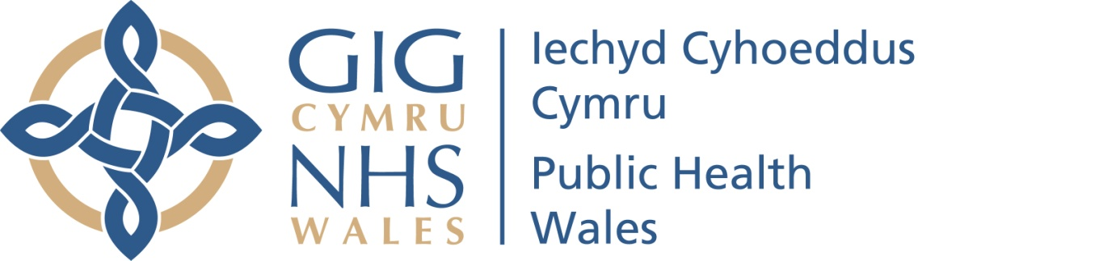

Protocol for the reporting and oversight of Internal and External Functions within Public Health Wales

May 2022
Version: 1 (Draft)

Introduction
The purpose of this document is to outline the governance arrangements relating to the Internal and External Audit activity within Public Health Wales.
This will cover:
- Oversight of all programmed Audit activity;
- Receipt and consideration of final reports resulting from audit activity;
- Monitoring and reviewing of the implementation of actions and findings from audit activity.

Oversight of the Audit Programmed Activity
The Audit and Corporate Governance Committee (ACGC) and has overall oversight of the Audit programme of work on behalf of the Board.
ACGC’s oversight role is to:
- Ensure that there are effective Internal and External Audit functions that meets the standards set for the NHS in Wales.
- Oversee the results of audit and assurance work, and ensure that the implications of the findings of wider audit and assurance activity relevant to the Trust’s operations are considered.
- Seek assurance on behalf of the Board on the adequacy of executive and managements response to issues identified by audit, inspection and other assurance activity, including ensuring timely implementation of any actions.

ACGC achieve this through:
- Considering and approving the Internal Audit Work Plan for activity, on an annual basis, and reviewing the progress of the Internal Audit work plan through regular progress reports.
- Receiving and considering the Head of Internal Audit Annual Opinion, and the summary of Audit activity contained within the Annual Governance Statement.
- Receive regular updates from Audit Wales on relevant External Audit activity through regular progress reports.
- Ensuring all relevant audit activity is brought to the attention of the Board and other Committees of the Board. This will be achieved through the Committee Chairs report to Board, and oversight of the Internal and External Audit Work Plans, which identifies onward circulation and consideration of reports by the Board and its Committees.
- Providing assurance to the Board through the Committee Chairs report, and the Committee Annual Report as to the effectiveness of Audit functions.
- Providing comment and suggestions to the Board for development and quality improvement of audit functions.

Consideration of Final Reports
ACGC receives all final reports following audit reviews, including the results of internal and external audit.
All final reports are also sent to the Chief Executive, and are submitted to a Business Executive Team meeting.
The role of ACGC is to provide assurance to the Board on the adequacy of executive and managements response to issues identified by audit, inspection and other assurance activity, and to have oversight of the implementation of actions resulting from such reviews.
ACGC is responsible for:
- Assurance that any actions following reviews are appropriately considered and acted upon by Public Health Wales, to ensure the ongoing development and improvement of the organisations governance arrangements. This includes scrutiny of the adequacy of executive and managements response to issues identified by audit, inspection and other assurance activity.

ACGC achieve this through:
- All Audit reports are reported to the ACGC for assurance.
  - If the report is No or Limited assurances, and / or high risk actions, the report will be placed on ACGC agenda for discussion.
  - If the report is reasonable, substantial and does not contain any high priority actions, the report will be reported to ACGC in the ‘to note’ section.

Remit Committees
Where the subject matter of an audit report falls within the remit of one of the other Board Committees, the report is also submitted to that Committee, following consideration at ACGC.
The role of the Remit Committee is to receive the report and to consider the recommendations made in the context of its work plan, and the areas of focus within its remit. Where relevant, the information contained in the reports will then be used to inform discussions of items on the work plan for the Committee.
In receiving the reports, the Remit Committee will apply the same approach outlined above to determine if the matter requires discussion at a Committee meeting or to be reported in the to note section for information.

Monitoring and Implementation of Action
The Audit Action Log enables the tracking of progress against agreed management actions. ACGC has oversight of the log, to receive assurance on progress and timeliness of the implementation of actions identified through audit activity.
The Business Executive Team are responsible for monitoring the Audit Action Log and approve any changes to deadline dates, and the closure of any completed actions.
The Board Business Unit will manage the process for updating the log and retain the master copy of the log.
The Audit Action Log will be reported to the Business Executive Team a minimum of quarterly (June, September, December, March) for monitoring and to approve any changes to deadline dates, and the closure of any completed actions. The Executive Lead for each report will and will liaise with their team and update the log quarterly, to in accordance with the timescales set.
The Audit action Log will be reported in full to the ACGC at least twice yearly, In September (Reporting period March – August) and March (Reporting period September to February) , along with a covering report highlighting any risks / issues, and a summary of changes since the last review.

Review of this protocol and Feedback

This protocol will be reviewed at least annually to ensure it continues to meet the needs of the organisation.

We welcome any feedback about this protocol and are happy to respond to any queries in relation to it. Please email the Board Secretary and Head of Board Business Unit at
PHW.CorporateGovernance@wales.nhs.uk

