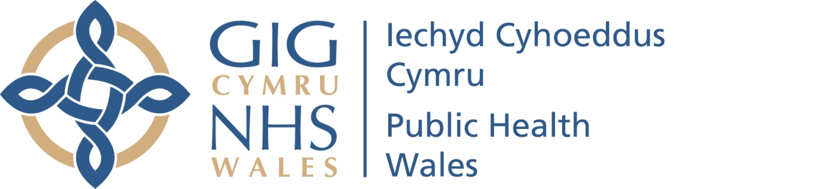

PROTOCOL FOR RESERVING MATTERS TO A PRIVATE BOARD (and Committee) MEETING

May 2021

Version 1

Introduction

In accordance with the Public Health Wales Standing Orders, Public Health Wales holds its Board meetings in public. Public Health Wales’ Standing Orders provides, at paragraph 7.5.2 the basis to meet and discuss relevant items in private. This is sometimes known as a ‘Private Board meeting’. The legal basis of this section of the Standing Orders is The Public Bodies Act (Admission to Meetings) Act 1960, section 1 (2).

There will be occasion when some of the organisation’s business is more appropriately considered in private session; this is to ensure that business considered is not prejudicial to the public interest - in other words that undue harm or influencing of the public unfairly does not take place.

This document has therefore been prepared to help identify the reasons that are most likely to apply to material considered by the Board in private meetings.

Public Health Wales’ Values and Transparency

Our values are ‘working together, with trust and respect, to make a difference’. We operate on the basis that transparency and openness is at the heart of our governance and decision making approach; and work on the basis everything is discussed within the Public Board meeting unless there is a specific reason not to do so.

Factors to consider when determining if a matter should be reserved for a Private Board meeting

In determining if a matter should be reserved for the Private Board agenda, there are a number of factors to consider including:

- Does the item or materials include personal data;
- Is there confidential or commercial sensitivity;
- Would the item undermine public confidence or cause undue; concern or potential harm to the public;
- Are there reputational issues to be considered – either of Public Health Wales or of other individuals, partners of stakeholders;
- Are the documents in draft which will be published in the future;
- Does the item include legal advice or is it legally privileged;
- Could the matter be prejudicial to the conduct to affairs;
- Is the disclosure of the matter inhibited by law.

The list is not exhaustive and is aimed to provide example of factors that may be considered.
It may be that some matters are held in Public session but the documents may be withheld from public availability until such time the document if in final form and published; for example a draft report.

Management of Board meetings held in Private
When the Board comes together for formal meetings, the majority of agenda items will be taken in public, which accounts for the majority of formal Board meeting time. Board papers will include a formal rationale for the reasons for taking an item in private session. The Agenda for both public and private sessions of the Board are published to our website.

There may be occasions when a private Board meeting may be convened without Public notice in order the Board can consider any urgent business and fulfil its legal and statutory roles.

Decision to consider items in private session

The final decision on whether material shall be discussed in private or public session shall be made by the Chair supported by Chief Executive, having taken advice from the Board Secretary and Head of Board Business Unit and lead Executive Officer, in accordance with this protocol. Advice may also be sought from any other member of staff or professional advisor including the Chief Risk Officer who is the designated data Protection Officer for the organisation.

Board papers will make clear the reason for an item being taken in Private session and where relevant the date in which the information may be made public, for example the publication of a report.

Review of this protocol and Feedback

This protocol will be reviewed annually periodically to ensure it continues to meet the needs of the organisation and remains consistent with the spirit of our Regulations and Standing Orders. A log of items considered in private session will be maintained and analysed to inform the annual review.

We welcome any feedback about this protocol and are happy to respond to any queries in relation to it. Please email the Board Secretary and Head of Board Business Unit at PHW.CorporateGovernance@wales.nhs.uk

