



 |  |  |  |  | Name of Meeting  Board
Date of Meeting
28 September 2023
Agenda item:
4.2.3
Update to the Public Health Wales Standing Orders and Reservations and Delegations of Powers
Executive lead: |  |  | Paul Veysey – Board Secretary and Head of the Board Business Unit
Author: |  |  | Paul Veysey – Board Secretary and Head of the Board Business Unit
Approval/Scrutiny route: |  |  | - BET on 6 September 2023 to consider and to Recommend adoption of the changes to Board  - ACGC on 19 September 2023 for Recommendation to the Board  - Board for Adoption on 28 September 2023
Purpose
To present to the Committee the revised Standing Orders and Reservations and Delegations of Powers issued by Welsh Government and to identify the changes proposed.
Recommendation:
APPROVE | CONSIDER |  |  | RECOMMEND |  | ADOPT | ASSURANCE
The Board is asked to:

- Consider the proposed revisions to Standing Orders and Reservations and Delegations of Powers
- Adopt the proposed revised Standing Orders and Reservations and Delegations of Powers.

Link to Public Health Wales Strategic Plan

Public Health Wales has an agreed strategic plan, which has identified seven strategic priorities and well-being objectives.

This report contributes to the following:
Strategic Priority/Well-being Objective |  | All Strategic Priorities/Well-being Objectives
Summary impact analysis

Equality and Health Impact Assessment |  | An Equality and Health Impact Assessment has been completed and can be found here.
Risk and Assurance |  | The Standing Orders and Scheme of Reservation and Delegation of Powers provides assurance that appropriate arrangements are in place within the organisation to make decisions.
Financial implications |  | N/A
People implications |  | N/A

Purpose / situation

The Welsh Government has issued revised Model Standing Orders and Reservation and Delegation of Powers to all health bodies in Wales.

The purpose of this paper is to set out the changes required to the current Standing Orders in order for the Committee to recommend the proposed changes to the Board for adoption on 28 September 2023. The Business Executive Team also considered the proposed changes on 6 September 2023, and the Audit and Corporate Governance Committee considered on 19 September 2023, and both agreed to recommendation to the Board.

Background

The Standing Orders and Reservation and Delegation of Powers (SOs), together with a range of other framework documents, are designed to translate the statutory requirements set out in Public Health Wales National Health Service Trust (Membership and Procedure) Regulations 2009 (2009/1385) as amended into day-to-day operating practice. Together with the adoption of a Schedule of decisions reserved to the Board of directors; a Scheme of decisions to officers and others; and Standing Financial Instructions (SFIs), they provide the regulatory framework for the business conducted by the Trust.

The current Public Health Wales NHS Trust SOs were adopted by the Board in May 2021, following the issue of revised model SOs from Welsh Government. These are our current Standing Orders and can be found here.

Whilst Model Standing Orders are generally reviewed, updated and issued by Welsh Government on an annual basis, no Model Standing Orders were issued to health bodies in 2022.

Welsh Government have however issued revised Model Standing Orders for 2023, which the Trust must incorporate and adopt.

Description/Assessment

Attached at appendix 1 are our current Standing Orders with the 2023 changes highlighted in red.

Key Changes

The following table identifies the key changes made by the 2023 Model Standing Orders;

Section | Changes
Throughout | All references to Community Health Councils have been amended to refer to the new replacement Citizens Voice Body for Health and Social Care Wales (to be known as Llais).
Statutory Framework | Vii) has been added to reflect the new Duty of Quality, the new Duty of Candour, the creation of the new Citizens Voice Body for Health and Social Care Wales (to be known as Llais) and the appointment of statutory vice-chairs for NHS Trusts.
NHS Framework | xxiii) has been updated to include the NHS Values and Standards of Behaviour Framework, the Health and Care Quality Standards, the NHS Risk and Assurance Framework and the NHS planning and performance management systems.
Membership of the Trust | 1.1 has been updated to reflect the composition of the Trust as the Chair, Vice Chair, 6 other Non-Executive Directors and 6 Executive Directors.
Working in Partnership | 6.1 has been extensively updated to incorporate the changes necessary to reflect the move from Community Health Councils to Llais.
Annual General Meeting | 7.2.5 has been amended to include a provision that the AGM is to take place by 30th September 2023.
Matters Reserved to the Board | 11. has been amended to ensure any action necessary in relation to a declaration of interest is addressed by the Chair. As currently drafted, the Board was to address the issue (which is incorrect).  23 and 24 have been clarified and reworded to show the Renumeration and Terms of Service Committee will appoint the officer members of the Board and will appoint, appraise, discipline and dismiss any other board level appointments and other senior employees in accordance with Ministerial Instructions.

The changes to the Standing Orders are therefore have very little impact upon the Trust and the ongoing exercise of its functions.

Deviations from the Model Standing Orders

The extent to which NHS bodies can deviate or customise their SOs is limited. The table below identifies the current Board approved deviations from the Model Standing Orders. It is proposed PHW should continue to observe these deviations.

Section | Previous Standing Orders |  | Revised Standing Orders |  | Comment
Para 7.4.3 |  | 7 Days for publication of agendas |  | 10 Days for publication of agendas |  | Proposed to remain at 7 days – which is realistic and remains consistent with internal management / approval timescales

Well-being of Future Generations (Wales) Act 2015

This work has been put together following the five ways of working, as defined within the sustainable development principle in the Act, in the following ways:

 | The Standing Orders and Reservation and Delegation of Powers provide the organisation with a long-term framework within which it operates
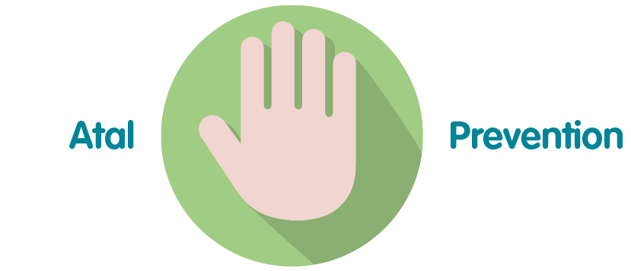 | The Standing Orders and Reservation and Delegation of Powers provide staff with guidance to prevent non-compliance
 | The Standing Orders and Reservation and Delegation of Powers ensure decision making is integrated across the organisation
 | The Standing Orders and Reservation and Delegation of Powers are based on the model standing orders issued by Welsh Government, which were reviewed and developed on a collaborative basis.
 | The Standing Orders and Reservation and Delegation of Powers are based on the model standing orders issued by Welsh Government, which were reviewed and developed in conjunction and consultation with relevant stakeholders.

Recommendation

The Committee is asked to:
The Board is asked to:

- Consider the proposed revisions to Standing Orders and Reservations and Delegations of Powers
- Adopt the proposed revised Standing Orders and Reservations and Delegations of Powers.

