 |  |  |  | Name of Meeting  Board
Date of Meeting
26 November 2020
Agenda item:
3.6.4 261120
Annual Equality Report 2019-20 & Annual Workforce Report 2019 - 20
Executive lead: |  | Neil Lewis, Acting Director of People and Organisational Development
Author: |  | Sarah Morgan, Diversity and Inclusion Manager
Approval/Scrutiny route: |  | The Annual Equality Report and Workforce Report have both been reviewed by the Business Executive Team; both of which they were content to recommend to Board for approval.
Purpose
The purpose of this paper is to provide background explanation to accompany the Annual Equality Report 2019-20 and Annual Workforce Report 2019 - 20

Recommendation:
APPROVE | CONSIDER |  | RECOMMEND |  | ADOPT | NOTE
The Board is asked to:
- Approve the Annual Equality & Annual Workforce Reports for publication.

Link to Public Health Wales Strategic Plan

Public Health Wales has an agreed strategic plan, which has identified seven strategic priorities.

This report contributes to the following:
Strategic Priority | 7 - Building and mobilising knowledge and skills to improve health and well-being across Wales
Strategic Priority | Choose an item.
Strategic Priority | Choose an item.
Summary impact analysis

Equality and Health Impact Assessment | An EQIA is not required as the plan is focused on Equality, and no decision is required.
Risk and Assurance | As a Public Body, we are legally obligated to produce an Annual Equality Report, and information about the diversity of our workforce. Failure to do this would link to risk number 727: There is a risk that Public Health Wales will not comply with its statutory and regulatory obligations to such a degree that it fails to achieve its strategic priorities
Health and Care Standards | This report supports and/or takes into account the Health and Care Standards for NHS Wales Quality Themes
Health and Care Standards | Theme 6 - Individual Care
Health and Care Standards | Theme 7 - Staff and Resources
Health and Care Standards | Choose an item.
Financial implications | Provision has been made in the budget for design and publication costs.
People implications | None

Purpose / situation

The purpose of this paper is to provide background explanation to accompany the Annual Equality Report 2019-20 and Annual Workforce Report 2019-20.

Background

As part of our obligations under the Public Sector Equality Duties, we are required to publish an Annual Equality Report, detailing the work the organisation has undertaken to further advance equality. The organisation is also required to publish annual data on the diversity of workforce. The Workforce Report is presented as a separate document, in the same way it was for 2018-19.

Description/Assessment

The attached Annual Equality Report contains contributions from various parts of the business, which has been provided via the departmental Equality Champions and gives an account of the work undertaken to further advance equality, grouped by Protected Characteristic.

The report is written retrospectively to cover the period between 1 April 2019 – 31 March 2020. References are made in the report to events which have since happened but would not have happened during the reporting period.

The second report presented is the Annual Workforce Report, which contains information on the diversity mix of our organisation, using data obtained from the Electronic Staff Records (ESR) and TRAC online recruitment system. This report also contains information on the work undertaken within the organisation to create a diverse and inclusive culture, where people can give of their best at work.

Both reports need to be published by the 31 March 2021 in line with the requirements set out in the Public Sector Equality Duties 2011.

Well-being of Future Generations (Wales) Act 2015

This report contributes /will contribute to the following Public Health Wales well-being objectives
Goal 3 - Support the NHS to deliver high quality, equitable and sustainable services
Goal 7 - Strengthen our role in global health and sustainable development
Choose an item.

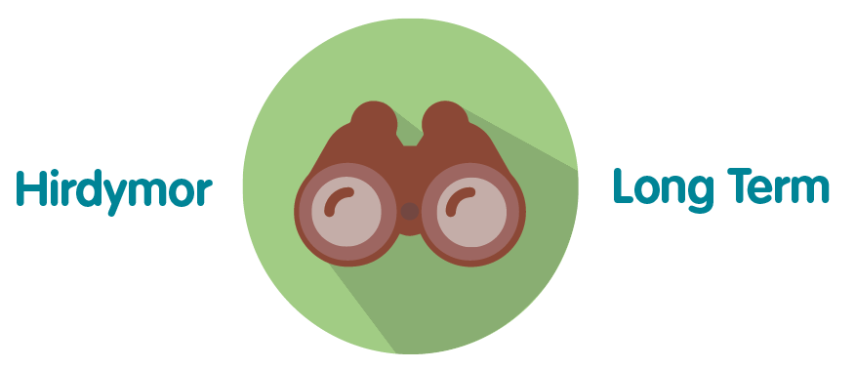 | The report sets out work that has been undertaken, as well as work planned to continue in a sustained way in the future
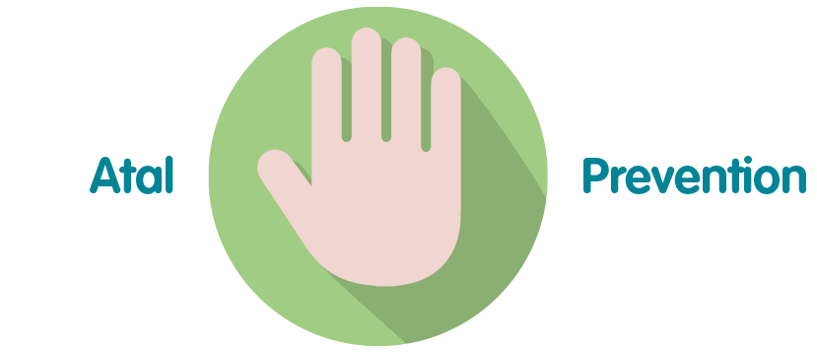 | By focusing on the work undertaken with the various protected characteristics, enables us to ensure equity of access to our services, thus preventing problems in future
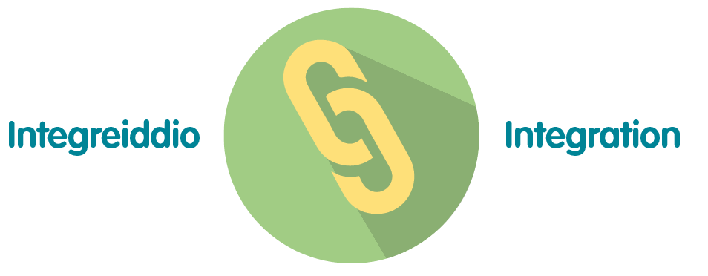 | The work focuses on all of the Well-being goals, in particular, a more equal Wales.
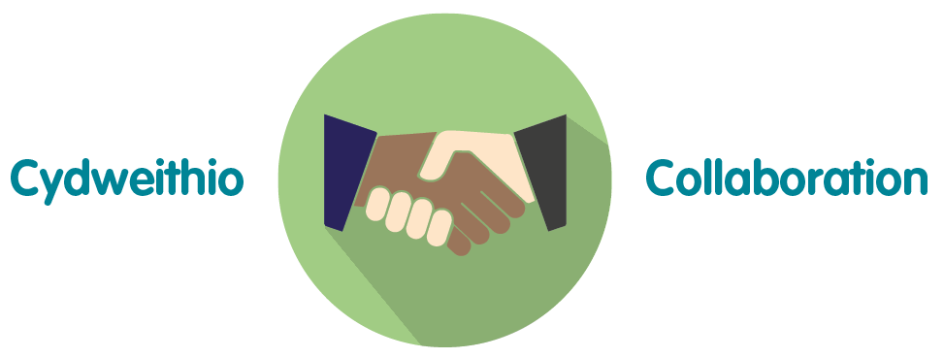 | There are examples throughout the report showing collaborative working, between different parts of the organisation, and also with other organisations.
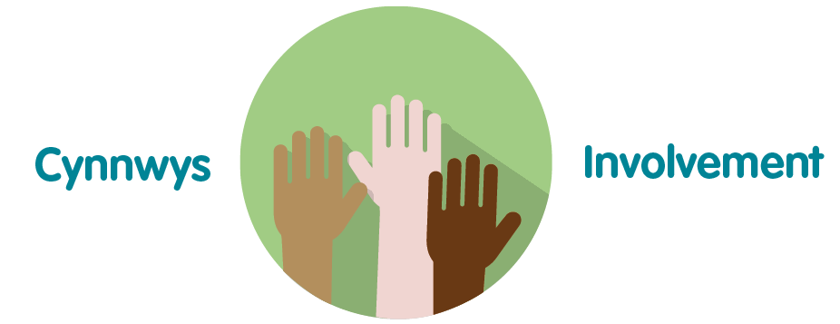 | The report explains in detail how it has involved diverse stakeholders and worked with them to further develop and inform people of our services.

Recommendation

The Board is asked to:

- Approve the Annual Equality & Annual Workforce Reports for publication.

