 |  |  |  | Name of Meeting  Board
Date of Meeting
26 November 2020
Agenda item:
3.6.3 261120
Risk Management Policy
Executive lead: |  | Rhiannon Beaumont-Wood, Executive Director, Quality, Nursing and Allied Health Professionals
Author: |  | John Lawson, Chief Risk Officer
Approval/Scrutiny route: |  | Rhiannon Beaumont-Wood, Executive Director, Quality, Nursing and Allied Health Professionals  Business Executive Team on the 6 October 2020.  Audit and Corporate Governance Committee considered the revised Policy at its meeting on 15 October 2020. The Committee endorsed the policy, recommending it to the Board for approval.  The Audit and Corporate Governance Committee also considered the revised Risk Management Procedure on 15 October. The Committee approved the revised procedure.
Purpose
This paper introduces the revised Public Health Wales Risk Management Policy.
Recommendation:
APPROVE | CONSIDER |  | RECOMMEND |  | ADOPT | ASSURANCE
The Board is asked to:
- Approve the revised Risk Management Policy.

Link to Public Health Wales Strategic Plan

Public Health Wales has an agreed strategic plan, which has identified seven strategic priorities and well-being objectives.

This report contributes to the following:
Strategic Priority/Well-being Objective | All Strategic Priorities/Well-being Objectives
Strategic Priority/Well-being Objective | Choose an item.
Strategic Priority/Well-being Objective | Choose an item.
Summary impact analysis

Equality and Health Impact Assessment | No EHIA required
Risk and Assurance | These documents underpin the risk management system
Health and Care Standards | This report supports and/or takes into account the Health and Care Standards for NHS Wales Quality Themes
Health and Care Standards | Governance, Leadership and Accountability
Health and Care Standards | Choose an item.
Health and Care Standards | Choose an item.
Financial implications | There are significant financial implications to not managing risk effectively. This Policy underpins the Public Health Wales risk management system.
People implications | None

Purpose / situation

This paper introduces the Risk Management Policy. This document has been reviewed by the Business Executive Team on the 6 October and the Audit and Corporate Governance Committee on the 15 October; both of whom recommend it to the Board for approval. It should be noted that the accompanying Risk Management Procedure was approved by the Audit and Corporate Governance Committee on 15 October 2020.

Background

This document was originally approved by the Public Health Wales Board in July 2017 and is presented following a review conducted early in 2020.

Description/Assessment

Following the review conducted by the Chief Risk Officer and the organisation wide consultation process, some minor amendments have been made to reflect updates in some of the organisational governance arrangements and the Policy has been updated accordingly from the previous iteration.

Well-being of Future Generations (Wales) Act 2015

This work has been put together following the five ways of working, as defined within the sustainable development principle in the Act, in the following ways:

 | Effective management of risk will help to ensure that Public Health Wales long term strategy is successful.
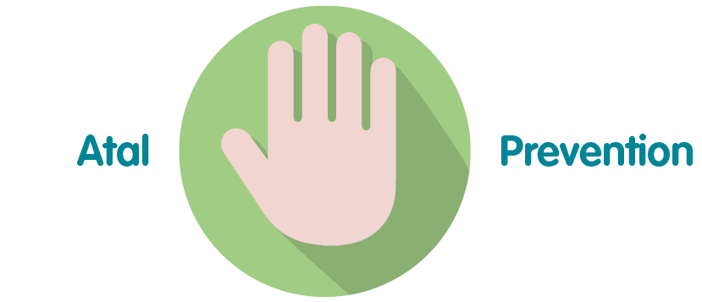 | An effective risk management system is essential to the identification and management of risks and helping to prevent issues arising that will stop the organisation achieving its strategic objectives.
 | These documents if properly implemented will help to ensure integration of risk management across the organisation
 | The risk management system which is underpinned by these documents has been developed in line with the expectations of both WG and other key stakeholders
 | The documents have been consulted on across the organisation prior to be presented for approval

Recommendation

The Board is asked to:

- Approve the revised Risk Management Policy.

