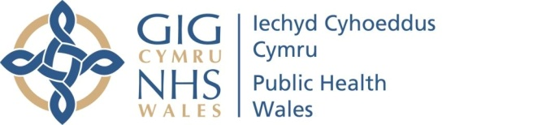 |  |  |  |  | Name of Meeting  Board
Date of Meeting
30 March 2023
Agenda item:
3.3
Performance and Insight Report

Executive lead: | Huw George, Deputy Chief Executive/ Executive Director Operations and Finance
Contributors: | Huw George, Deputy Chief Executive and Executive Director of Operations and Finance; Meng Khaw, National Director of Screening & Health Protection; Neil Lewis, Director of People and Organisational Development; Rhiannon Beaumont-Wood, Executive Director of Quality Nursing and Other Allied Health Professionals; Angela Fisher, Deputy Director of Finance; Ioan Francis, Head of Performance
Approval/Scrutiny route: | Business Executive Team (20 March 2023)
Purpose
Our Performance and Insight Report focuses on delivering actionable insights whilst identifying areas for further improvement across the following key performance themes;

- Maintaining a healthy and sustainable workforce
- Achieving value and impact through innovation
- Delivering organisational wide quality and access to high quality services
- Improved population health and well-being

The report is designed to be read in conjunction with the Performance and Assurance Dashboard.
Recommendation:
APPROVE |  | CONSIDER |  | RECOMMEND |  | ADOPT | ASSURANCE
The Board is asked to:

- Discuss and scrutinise the paper and provide feedback and comments.

Link to Public Health Wales Strategic Plan

Public Health Wales has an agreed strategic plan, which has identified seven strategic priorities and well-being objectives.

In order for Public Health Wales to deliver the strategic plan, effective performance management arrangements need to be in place to monitor and report on progress against achieving our strategic priorities to improve health outcomes. This intelligence is used to draw the Board’s attention to areas of underperformance and is fundamental for effective and efficient decision making.

This report contributes to the following:
Strategic Priority/Well-being Objective |  |  | All Strategic Priorities/Well-being Objectives
Summary impact analysis

Equality and Health Impact Assessment |  |  | An Equality and Health Impact Assessment is not required. Equality and Health Impact Assessments will be completed as part of delivery of the specific actions within the Plan.
Risk and Assurance |  |  | Our Strategic Risks are detailed within Our Strategic Plan and the Implementation Plan for the Test Trace Protect Strategy.
Health and Care Standards |  |  | This report supports and/or takes into account the Health and Care Standards for NHS Wales Quality Themes
 |  |  | All themes
Financial implications |  |  | An update on the organisation’s financial performance is enclosed
People implications |  |  | An update on the organisation’s people performance is enclosed

- Purpose / situation

Our Performance and Insights Report focuses on delivering actionable insights whilst identifying areas for improvement across the following key performance themes;
  - Maintaining a healthy and sustainable workforce
  - Achieving value and impact through innovation
  - Delivering organisational wide quality and access to high quality services
  - Improved population health and well-being

This approach supports the Board and its Committees in discharging their responsibilities. The reporting of the four key themes will see us align to the Welsh Government’s A Healthier Wales quadruple aims and key measures set out in the 2022/23 NHS Wales Performance Framework.
The report is designed to be read in conjunction with the Performance and Assurance Dashboard (PAD) and the Public Health Rapid Overview Dashboard. The themes are demonstrated throughout this month’s report and are also reflected in the PAD.
- Background

Access to high quality, timely and robust performance information is essential in providing assurance to our Executive Team and Board on our ongoing COVID-19 recovery, delivery of public health services and functions, and our role in improving population health and well-being.
Having strengthened our performance arrangements over the last 12-24 months through the successful development of the PAD we recognised the need to strengthen the accompanying Performance and Insight Report.
The February 2023 PAD can be accessed using the following Link, or by navigating from specific areas of interest in the report by selecting the following symbol , thus enabling direct access to the latest available performance information.
- Description/Assessment

Key points to consider in this month’s Performance and Insight Report are:
- Good progress continues to be reported in the delivery of our Strategic Plan milestones at month 11. Over 96% of IMTP milestones were reported as on track or complete in month 11. With 131 milestones to be delivered by year-end (38.97% of all milestones), these will be monitored closely since previous data shows that a green milestone has 33% chance of changing directly to red. 10 milestones were completed this month.
- Sickness absence reduced from 4.51% to 3.69% in February 2023, with the 12-month rolling sickness absence at 4.48%. Latest data showed that short term sickness absence accounted for 71% of absences. The People & OD Directorate will be working with Directorates with the highest levels of short-term absence to identify additional support or interventions in reducing short term absences.
- Approximately 51% of Public Health Wales staff have received the flu vaccine with uptake among front-line slightly higher at 53.5% (up from 47% and 46.4% respectively last month). Around 53% of staff have received the COVID-19 booster with uptake at over 59.3% for front-line staff.
- Staff appraisal compliance decreased from 72.1% to 71.5% in January 2023, following a slight increase in January 2023. Compliance remains below the 85% Welsh Government target.
- Compliance with the core suite of statutory and mandatory training remains above the 85% Welsh Government target at 89.6% (down 1.8% in-month). E-learning queries are being directed to the ESR All-Wales Support Team, in addition to the People and OD team carrying out two ESR drop-in sessions per month.
- The Gender Pay Gap Report has been published and shows the mean pay gap has reduced from 16.1% in 2021 to 11.8% in 2022, in line with the objective set in our Strategic Equality Plan.
- Our cumulative reported position at month 11 2022/23 is a net surplus of £132k (£162k in-month), with an anticipated breakeven position at year-end. The surplus is a combination of variances across a number of Directorates associated with the movement against spending plans, with the main under spend in Health Protection and Screening. Public Health Wales’ forecast year-end revenue position is a surplus of £0.150m which represents less than 0.1% of total annual budget. This is after the return of non-recurrent benefits of £2.487m to Welsh Government.
- Our capital funding for 2022/23 totals £5.679m with year to date spend at £4.126m. Capital funding is made up of £1.142m discretionary funding and £4.537m strategic funding. Of the £1.552m remaining £1.470m of additional orders have already been placed. There remains a focus to achieve a break-even capital position.
- Performance for our year to date Public Sector Payment Policy is above the statutory target at 96.17% (95.66% in month 11) and is expected to remain above target. Year to date agency spend as a percentage of total pay equates to 3.3% with a year-end forecast of 3.3%.
- COVID-19 and influenza incidents levels remain relatively stable with no significant COVID-19 incidents or outbreaks reported this month. However, multiple Omicron variants are co-circulating with XBB.1.5 the most frequent in the most recent week. Testing numbers remain relatively consistent and driven by symptomatic requirements. Turnaround compliance for non-rapids and rapids in hot labs were over 90% and 95%, respectively.
- Delivery of screening programmes continue despite the challenges of ongoing strike action. Snow conditions from 8-10 March 2023 meant that screening clinics had to be cancelled where local conditions were difficult.
- The AAA programme undertook a high number of screens in February 2023 (1,925), and has fully recovered the programme by end of March 2023 as planned. The programme has focused work to reduce backlog with additional clinics in specific areas. Plans are progressing well with the new screening site in Cardiff, with implementation from May 2023.
- Latest mandatory childhood vaccination data reported within the COVER 145 report (October – December 2022) showed that for children aged 1, uptake of the “6 in 1” vaccination remained below 95% at 94.6%, down 0.1% compared to the previous quarter. In children reaching five years of age this quarter, coverage of two doses of MMR was 90.2%. A number of system level actions have been undertaken to support improvements in uptake data since the data was published. This includes the response to the ongoing Vaccine Derived Polio Virus Type 2 (VPDV2) incident in London whereby the Wales Incident Management Team supported a catchup of missed immunisations for under 5s.
- One No Surprises Incident reported in February 2023 related to taking forward actions to address recommendations from the external review of the Tuberculosis (TB) outbreak and its management in the Llwynhendy area of Carmarthenhire dating back to 2010. This includes identifying any learning and informing the ongoing and future management of TB disease in Wales. The external review was published on January 26 2023, with the recommendations were accepted in full by both Public Health Wales and Hywel Dda UHB.

Further insights from the Performance and Assurance Dashboard can be found on page 2 – Key Performance and Insights Summary.
Performance and Assurance Dashboard (not publically available)
https://phw-tableau.cymru.nhs.uk/t/CorporateAnalyticsPreProduction/views/RecoveryDashboardLandingPage/LandingPage?:linktarget=_self&:embed=yes#1

Public Health Rapid Overview Dashboard (not publically available)
Public Health Rapid Overview Dashboard

- Well-being of Future Generations (Wales) Act 2015

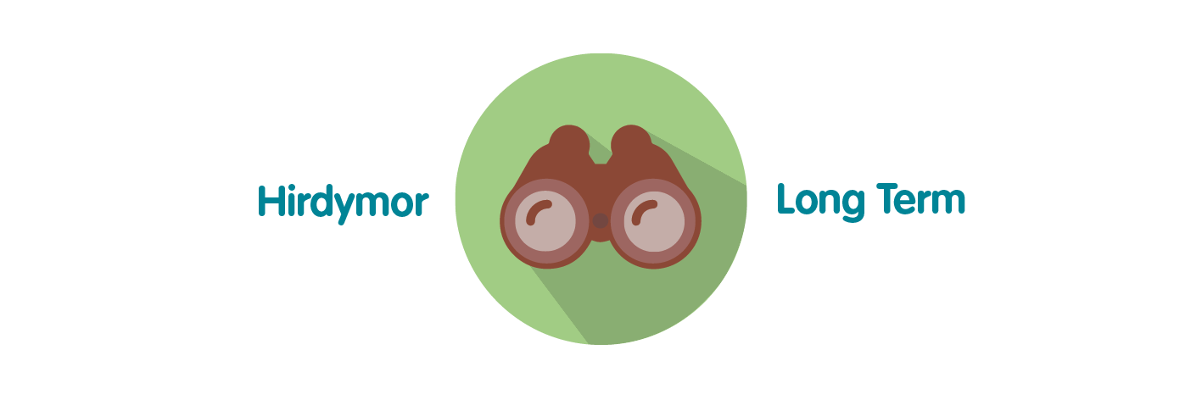 | Ensures Public Health Wales is able to successfully monitor the delivery of its functions; assess areas of underperformance; and can use this intelligence and knowledge to aid decision making.
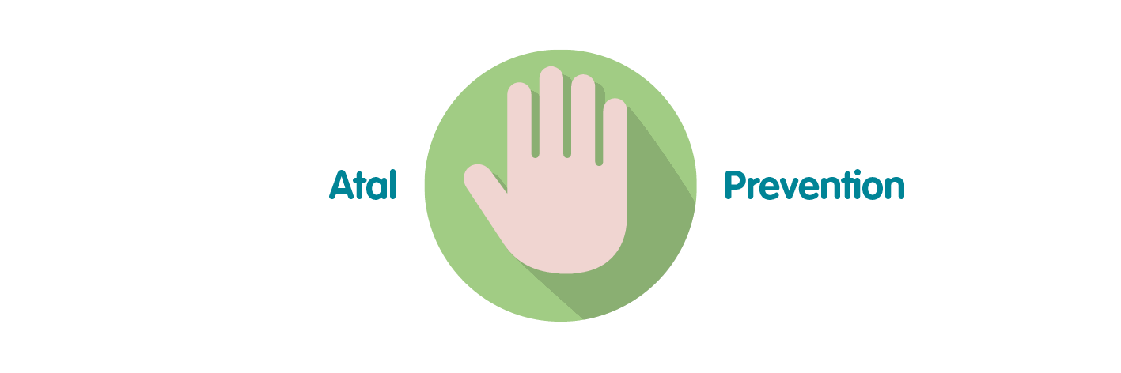 | Effective and efficient decision making by senior managers, Executive Team and the Board is paramount to successful performance of the organisation in order for it to achieve its purpose, whilst preventing the potential to cause harm through underperformance.
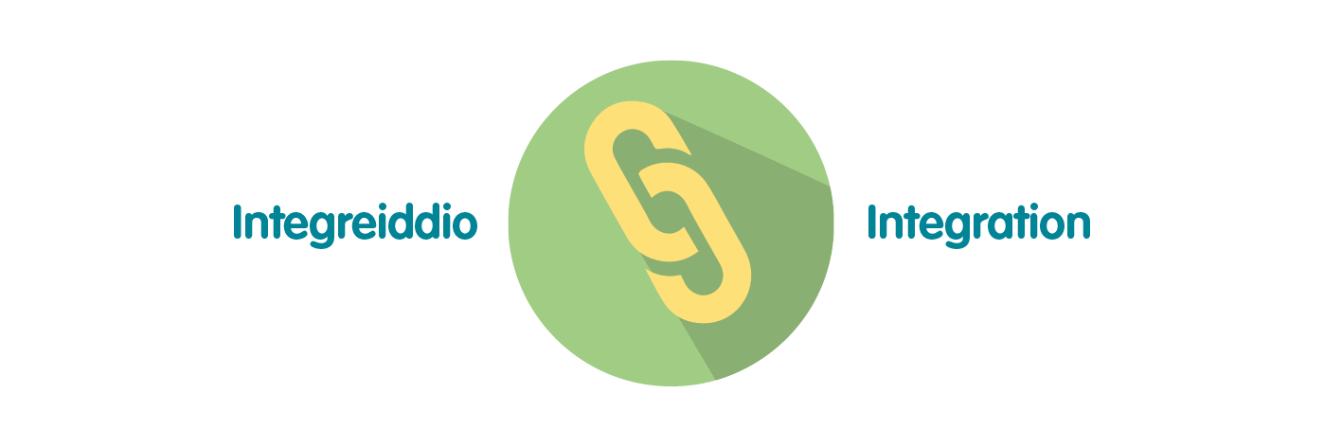 | The development of Public Health Wales’ Long Term Strategy and Integrated Medium Term Plan has been grounded in collaboration and integration across our workforce. To demonstrate that the organisation is achieving what it set out to achieve over the short, medium and long term, high quality monitoring and reporting of information is essential through the integrated performance report. This approach has been reflected in the approach to the pandemic response.
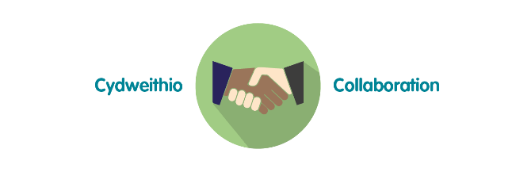 | Reporting of data and information through the integrated performance report requires collaboration across the organisation to ensure timely delivery of key service, quality, workforce and financial data. The potential for the development of business intelligence tools will require close working relationships with Directorates and especially Informatics to maximise potential.
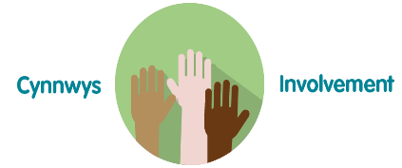 | To ensure compliance with the Welsh Audit Office Structured Assessment, agreeing and reporting Division / Directorate level performance measures will require involvement across the full breadth of the organisation. Monitoring and reporting against the strategic plan will involve working closely with staff to ensure accurate and timely intelligence for the Executive Team and Board.
- Recommendation

The Public Health Wales Board is asked to:

- Discuss and scrutinise the paper and provide feedback and comments.

