 |  |  |  |  | Name of Meeting  Board
Date of Meeting
17 December 2020
Agenda item:
3.2
COVID-19 Vaccination Programme - Update
Executive lead: |  | Andrew Jones, Interim Executive Director Public Health Services
Author: |  | Dr Richard Roberts, Head, Vaccine Preventable Disease Programme (VPDP)
Approval/Scrutiny route: |  | Business Executive Team
Purpose
This report provides an update on the COVID-19 vaccination programme, outlines NHS Wales’ progress and Public Health Wales (PHW) contributions
Recommendation:
APPROVE | CONSIDER |  | RECOMMEND | ADOPT |  | ASSURANCE
The Board is asked to:
- Receive assurance that the COVID-19 Vaccination programme has successfully launched in Wales.
- Note the significant contribution from Public Health Wales

Link to Public Health Wales Strategic Plan

Public Health Wales has an agreed strategic plan, which has identified seven strategic priorities and well-being objectives.

This report contributes to the following:
Strategic Priority/Well-being Objective | 5 - Protecting the public from infection and environmental threats to health
Strategic Priority/Well-being Objective | Choose an item.
Strategic Priority/Well-being Objective | Choose an item.
Summary impact analysis

Equality and Health Impact Assessment | Not undertaken
Risk and Assurance | Links to general risk for Public Health Service/ Health protection services and risks relating to the COVID response. Successful delivery of vaccination programme will positively impact on rates of COVID 19 within the population and mitigate current risks associated with high circulating levels. However, given the complexity of the programme this will take many months to realise.
Health and Care Standards | This report supports and/or takes into account the Health and Care Standards for NHS Wales Quality Themes
Health and Care Standards | Theme 1 - Staying Healthy
Health and Care Standards | Theme 3 - Effective Care
Health and Care Standards | Theme 6 - Individual Care
Financial implications | Pay and non-pay forecast 2020/21 £503,573. Full year £1,316,776 (includes posts agreed in PHW business case)
People implications | Additional posts agreed as part of PHW business case

Situation

This paper provides a high-level update on the COVID-19 vaccination programme in Wales, outlining the progress of NHS Wales’ and describing the contribution of Public Health Wales (PHW) The paper also includes updates on plans for vaccinating PHW staff and includes brief updates on the flu and childhood vaccination programmes.

Background

The long term response to the COVID-19 pandemic requires a safe and effective vaccine to be available for all who need it.

Rapid progress has been made in research of a large number of candidate COVID-19 vaccines and preparations for manufacture, with over 200 COVID-19 vaccine candidates against the SARS-CoV-2 virus to date, of which around 50 have entered clinical trials. Wales has participated in this research, providing leadership for the part of the Oxford AstraZenaca COVID-19 vaccine phase III trial based in Wales.

UK governments have announced the advanced purchase of seven different vaccines, utilising four different COVID-19 vaccine technologies, totalling over 350 million doses. The contracts announced include the Pfizer BioNTech and Oxford AstraZeneca vaccines. These are reported to be highly effective vaccines in Phase III trials, achieving 90% and 62-90% effectiveness respectively.

Public Health Wales has been involved in leading the planning for COVID-19 vaccine programme delivery in Wales. This has been exceptionally challenging due to the emerging nature of data on vaccine characteristics and of developing understanding of which individuals are most at risk of severe COVID-19 infection.

Assessment

The COVID-19 vaccination programme started on Tuesday 8 December 2020 in Wales and across the UK. The programme is large scale and ambitious, aiming eventually to offer COVID-19 vaccine to every adult in Wales. The delivery of the programme to priority groups will take several months.
Over 2,500 doses of vaccine were given on the first two days of the programme with all HBs having one vaccination centre operating. This was an extremely successful launch following 6 months of intensive planning by all partner agencies. Vaccine delivery will increase weekly as more vaccine is received from the manufacturer.
The Medicines and Healthcare products Regulatory Agency (MHRA) granted the Pfizer BioNTech COVID-19 vaccine temporary authorisation based on evidence of safety and effectiveness on Wednesday 25 November 2020. The UK has ordered 40 million doses of the vaccine, with Wales receiving a 5% share.
The Pfizer BioNTech vaccine is over 90% effective in preventing symptomatic COVID-19 disease, including in older individuals. We do not know if it prevents virus shedding or transmission, so we cannot currently relax existing control measures for individuals or localities. MHRA has updated its advice after two cases of anaphylaxis in healthcare workers in England on 2 December, both fully recovered.
The handling characteristics of the Pfizer BioNTech vaccine (which needs to be stored at -75C and transported on dry ice) means the programme is initially immunising NHS frontline and social care staff in large NHS premises staff. It will move to those age 80 years and over in mass vaccination community venues, before moving to include care homes once further vaccines are brought into play and vaccine stability for transport at normal fridge temperature (2-8C) is clarified. The JCVI priority groups are:
- Priority Group 1, which is residents in a care home and staff who are working in care homes for older adults and;
- Priority Group 2 which are those aged 80 years and over and frontline health and social care staff.
The programme will then deploy step wise down the age range, and include those under 75 in clinically extremely vulnerable and under 65 in at risk groups, then down to those age 50 and over to complete the first priority phase of the roll out in by Quarter 2 2021 (appendix 1).
The UK Government has also ordered 100 million doses of the Oxford AstraZeneca COVID-19 vaccine. The MHRA is now considering the large scale Phase III trial data, and a decision from the MHRA is awaited. If approved delivery may be later in December

Update on PHW contribution
PHW has supported the programme by providing leadership, expertise and advice to the programme board and work streams, with VPDP team members leading sub-groups for the COVID-19 Vaccine Programme Board on:
  - information resources for the public and health and social care workforce
  - surveillance
  - training
  - Patient Group Directions (PGDs) and protocols
  - the Welsh Immunisation System, developed by NWIS for invitation and data management.
Surveillance reporting of vaccine uptake, programme outputs and dashboards have been developed and delivered by VPDP and CDSC. Daily situational reporting (Sitreps) commenced covering day 1 of the campaign. These include adverse effects of vaccination. Communication, marketing and publications support has been provided by the Public Health Wales Communications Team. The Observatory Evidence Service also produced rapid reviews of evidence on mass vaccination programmes. Finance colleagues have supported with budget and financial planning.
A microsite has been developed to share key messages with the public and includes an area for professionals involved in vaccination who are not employed by the NHS and cannot access the VPDP intranet page for resources. This will eventually be superseded by NHS 111.
The team in VPDP have produced public and professional information (example below), surveillance reports and dashboards, training materials and guidance, and regulatory template documents including Patient Group Directions (PGDs) for health boards and trusts to use. There is usually a six week minimum lead in to make available these materials, but due to advanced preparation we had these materials ready within five days of the MHRA announcement by Monday 7 Dec. Health Boards are continuing with planning to address the significant operational challenges in expanding recruitment and venues.

COVID 19 vaccine delivery for Public Health Wales Staff.

JCVI have provided the definition of frontline staff as staff who have face to face clinical contact with patients/service users, this also includes laboratory staff who handle potential infected specimens. Front line staff within the Public Health Wales workforce have been identified through information held on the Electronic Staff Record and agreed through Divisional Directors or identified delegates. The areas identified with front line staff includes microbiology, screening, health protection and other staff who hold honary contacts who undertake clinical work with other organisations. (Relevant bank staff who are undertaking ‘front line’ work have also been included).

Staff information has been submitted to the Welsh Immunisation System (WIS) which is held by NWIS, which is the information system being used to manage the role out of the vaccine. Unlike our internal delivery plan for the influenza vaccine, due to the logistics of the storage and handling of the first available vaccine, we have been unable to deliver this in house. Therefore, have had agreement with Health Boards within NHS Wales that they will vaccinate our frontline staff. Discussions are ongoing in terms of staff access arrangements with individual Health Board Booking arrangements. Issues in gaining clear confirmation with regard to access have been escalated to the COVID-19 Programme Board and with individual Health Boards.

There are ongoing dynamic changes on a daily basis which make the plans for roll out very challenging. There is much of this Public Health Wales has no direct control over. Ensuring that Public Health Wales staff are not disadvantaged in terms of access to the vaccine has been raised with individual Health Boards and with the Programme Board.

Regular communications are being provided to staff and managers on the prioritisation process, information on the vaccine itself and access route to the vaccine. A Q&A session is planned for next week which staff will be able to join on a live basis.

When other vaccines become available in the near future which have less logistical challenges, Public Health Wales will assess whether it will be preferable for us to deliver the vaccine ‘in house’, as with the flu vaccine. This would provide the organisation with more control and the ability to be much clearer with our communication to staff
Influenza vaccination programme

The flu vaccination programme this year is the largest ever, and has already achieved the highest vaccine uptake ever in those age 65 and over at 74.3%, compared to 68.3% at the end of season last year, and 54.2% in under 65 at risk, also higher than last year. Over 750,000 adults and children have been vaccinated to date.
Uptake of influenza immunisation in children age 2 years has increased from 27.7% to 49.8%, in children age 3 years from 28.3% to 50.7%, and in primary school children aged 4-10 years from 69.3% to 72.4% compared to the same time period last year.
Welsh Government have procured over 400,000 additional flu vaccines this year, and have extended eligibility to everyone aged 50-64 years from 1 December.
Routine childhood vaccination programme

The uptake of routine immunisations in pre-school children has been stable and within the range of previous trends as reported via PHW VPDP enhanced surveillance since May 2020.
Monitoring suggests that the enhanced safety measures put in place in Wales have maintained public trust, with parents and carers continuing to bring their pre-school children to immunisation appointments and reflects the hard work and dedication of all the staff in primary care and child health departments.
However, timeliness of vaccinations tends to decrease over the winter period whilst practices are prioritising influenza vaccination sessions. The impact of this extra workload on general practices in combination with COVID-19 restrictions may result in further decreases in timeliness.

Recommendations

The Board is asked to:
- Receive assurance that the COVID-19 Vaccination programme has successfully launched in Wales.
- Note the significant contribution from Public Health Wales

Appendix 1

Table: JCVI priority groups
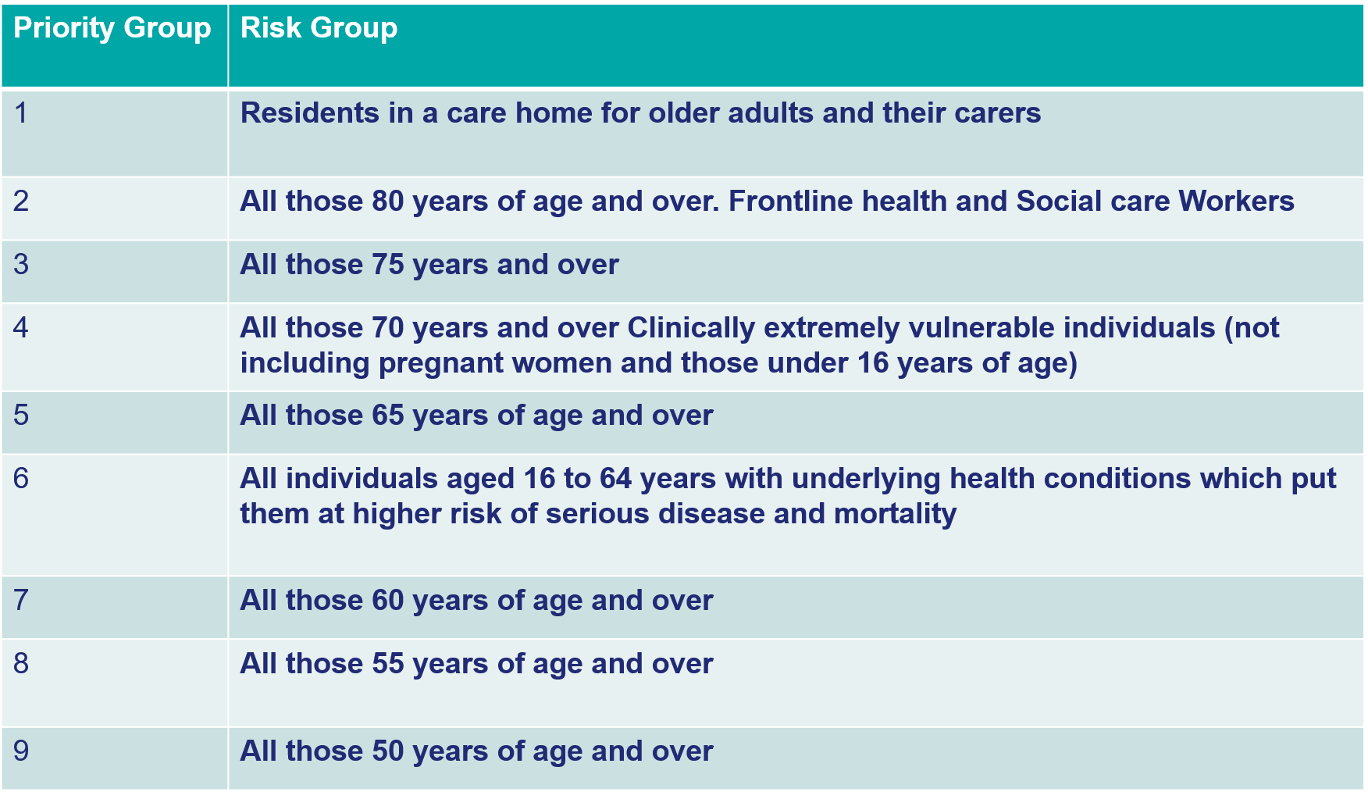
Source: https://assets.publishing.service.gov.uk/government/uploads/system/uploads/attachment_data/file/941450/Greenbook_chapter_14a_v2.pdf

An example of one of the resources developed by PHW:

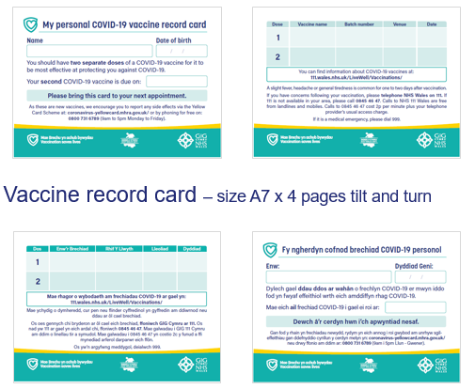

Written Statement: COVID-19 Vaccine Deployment in Wales (2 December 2020) | GOV.WALES
https://phw.nhs.wales/topics/immunisation-and-vaccines/covid-19-vaccination-information/

